
The University of Faisalabad

Department of Computational Sciences
BSAI 6th Semester

LAB MANUAL

Course Title: Data Mining Course Code: DS-303

Name : Ayesha Imran
Registration no : 2023-BS-AI-011
Submitted to : Sir Arham
Degree : Bachelors of Artificial Intelligence
Section A
Batch : 2023-2027

TABLE OF CONTENT

LAB NO: | TITLE | PAGE NO:
01 | Knime Introduction | 03
02 | CRISP-DM | 08
03 | Data Cleaning | 17
04 | Normalization, standardization, discretization, summary stats | 20
05 | Market Basket Analysis | 27
06 | Apriori Algorithm | 30
07 | FP-Growth | 32
08 | Python Basics | 35
09 | Decision Tree Classifier for Customer Purchase Prediction | 45
10 | Email Spam Detection using Naïve Bayes and K-Nearest Neighbors (KNN) | 51
11 | Credit Card Fraud Detection using Support Vector Machine (SVM) | 57
12 | Customer Segmentation using K-Means and Hierarchical Clustering | 65
13 | Anomaly Detection in Banking Transactions using Distance-Based Outliers and Isolation Forest | 72
14 | Social Media Data Mining and Sentiment Analysis for Product Reviews | 79
15 | Comparative Analysis of Multiple Data Mining Models for Industry-Based Prediction | 91

LAB-1
Knime Introduction

Introduction to Data Mining
Data Mining is the process of extracting useful information, patterns, and knowledge from large amounts of data. It is an important part of the field of Data Science and helps organizations make better decisions.
In simple words, data mining means analyzing data to discover hidden patterns and relationships that are not easily visible.

Why Data Mining is Important
Today, huge amounts of data are generated every day. Data mining helps to:
- Identify trends and patterns
- Improve decision making
- Predict future outcomes
- Understand customer behavior
Data mining process:
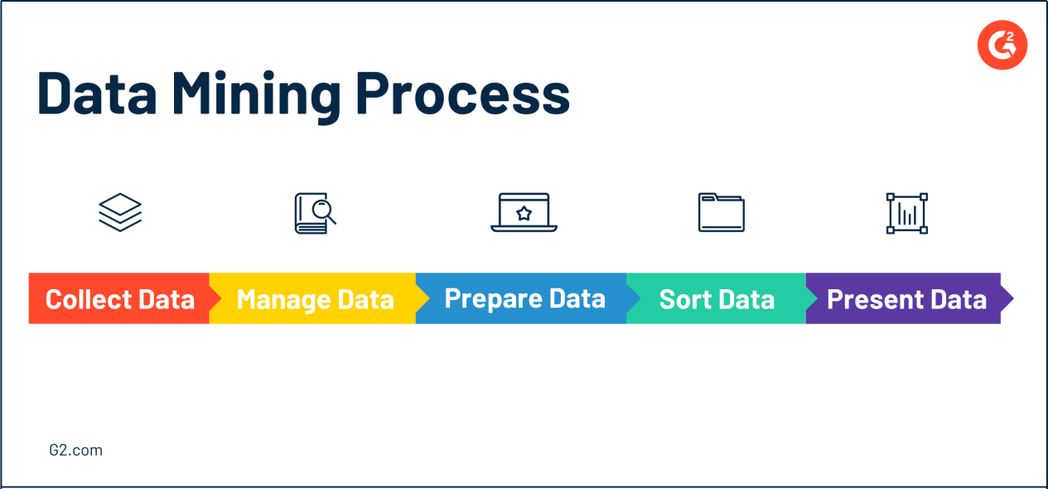

Introduction to software :
KNIME (Konstanz Information Miner) is an open-source data analytics platform used for data mining, data analysis, and machine learning. It provides a user-friendly, graphical interface where users can create workflows by connecting different nodes instead of writing code. KNIME allows users to easily perform tasks such as data preprocessing, visualization, and model building, making it suitable for both beginners and professionals. It is widely used in business intelligence and data science for analyzing large datasets and extracting meaningful insights.
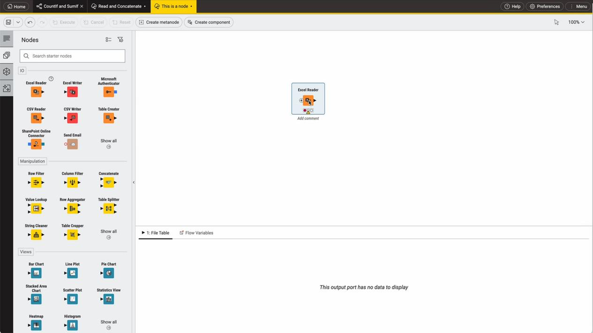

Dataset Overview: Retail Sales Dataset
https://www.kaggle.com/datasets/mohammadtalib786/retail-sales-dataset
This dataset contains transactional retail data that captures customer purchases across different countries. Each record represents a single item purchased within a transaction.

Key Attributes (Columns)
The dataset includes the following main features:
- UserId → Unique identifier for each customer
- TransactionId → Unique ID for each transaction
- TransactionTime → Date and time when the purchase was made
- ItemCode → Unique code for each product
- ItemDescription → Name/description of the product
- NumberOfItemsPurchased → Quantity of items bought in a transaction
- CostPerItem → Price of a single item
- Country → Country where the transaction occurred

What This Dataset Represents
This dataset reflects:
- Customer buying behavior
- Product demand patterns
- Sales distribution across countries
Each row corresponds to a single product within a transaction, meaning one transaction may have multiple rows.
- Import Dataset in KNIME
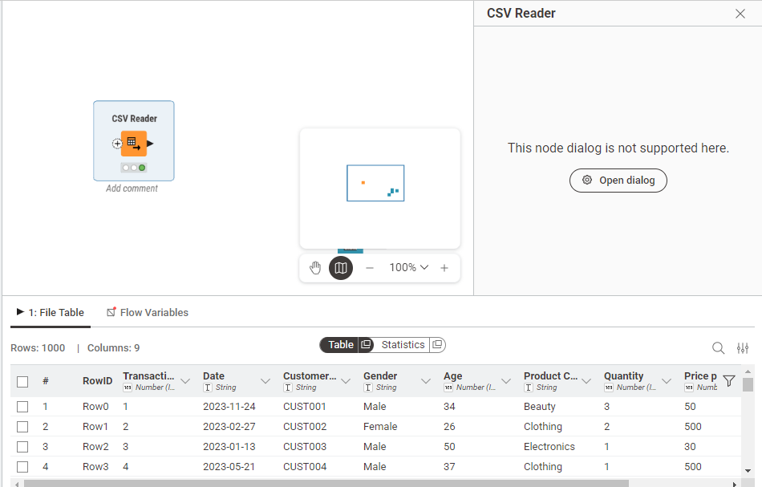
- Identify Data Types
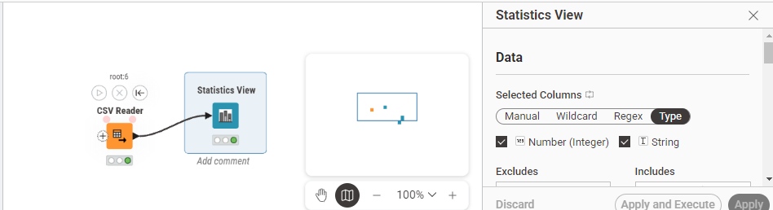

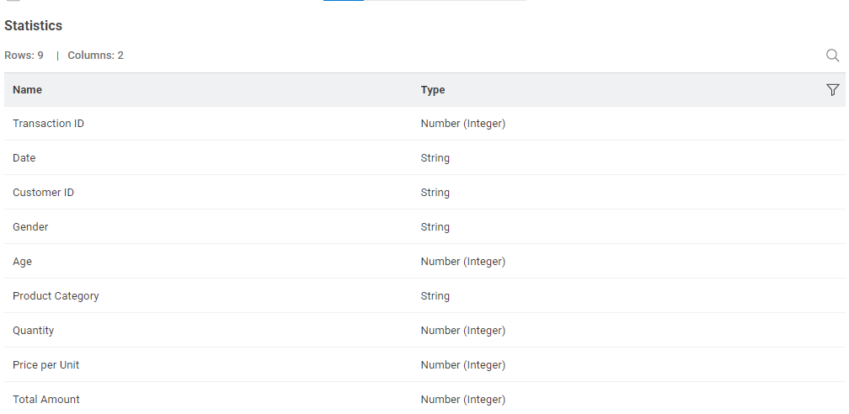
- Generate Summary Statistics
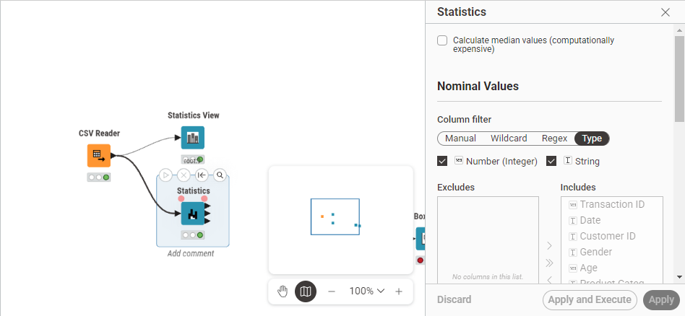
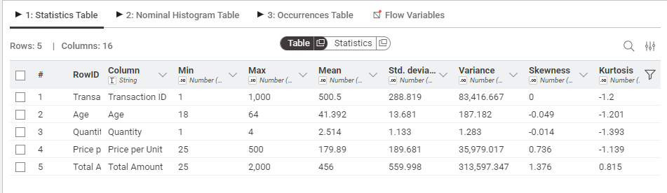
- Explore Attributes (Data Analysis)
- Histogram (Numeric Data)
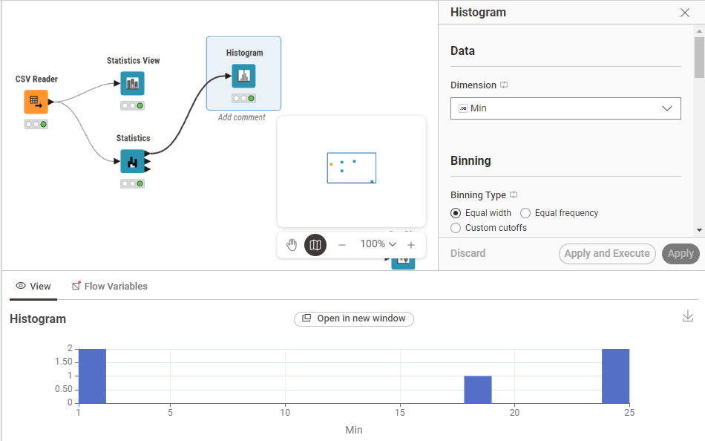
- Box Plot
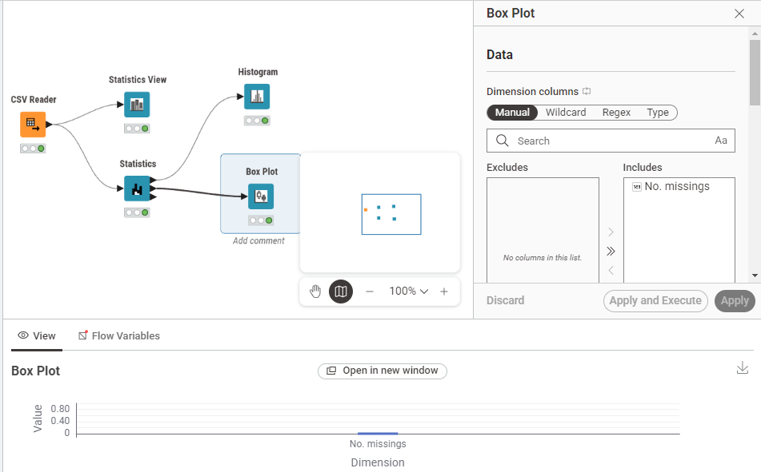

- Bar Chart
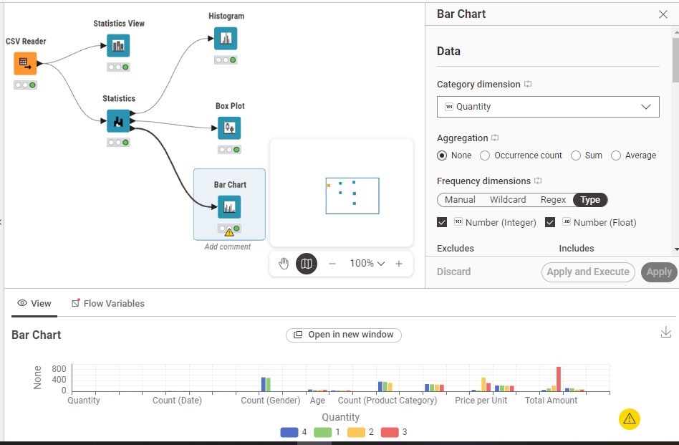

LAB-2
CRISP-DM
Dataset : https://www.kaggle.com/datasets/sarahashmi/churn-modeling-csv

Types of Data
Data can be classified into different types based on structure and format:

1. Structured Data
- Organized in tables (rows & columns)
- Easy to store and analyze
- Example: databases, Excel sheets

2. Unstructured Data
- No fixed format
- Harder to analyze
- Example: text, images, videos, audio

3. Semi-Structured Data
- Not fully structured but has some organization
- Example: JSON, XML files

Other Common Data Types:
- Numerical Data
  - Numbers (e.g., age, salary)
  - Can be discrete or continuous
- Categorical Data
  - Labels or categories
  - Example: gender, color, yes/no
- Time-Series Data
  - Data over time
  - Example: stock prices, temperature

Real-World Data Mining Applications
Data mining is widely used in many fields:

1. Business & Marketing
- Customer segmentation
- Sales prediction
- Targeted advertising

2. Healthcare
- Disease prediction
- Patient diagnosis
- Medical image analysis

3. Banking & Finance
- Fraud detection
- Credit scoring
- Risk analysis

4. E-commerce
- Product recommendation systems
- Customer behavior analysis

5. Education
- Student performance prediction
- Personalized learning systems

6. Social Media
- Sentiment analysis
- Trend detection

CRISP-DM Phases in Orange (with practical steps)
CRISP-DM has 6 phases.

1. Business Understanding
Goal: Predict customer churn (Yes/No)
- Problem: Which customers will leave the bank?
- Target variable: Exited (Churn)
- Data Understanding
- Collect and explore data
- Check data quality and patterns
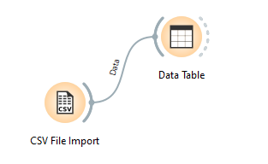
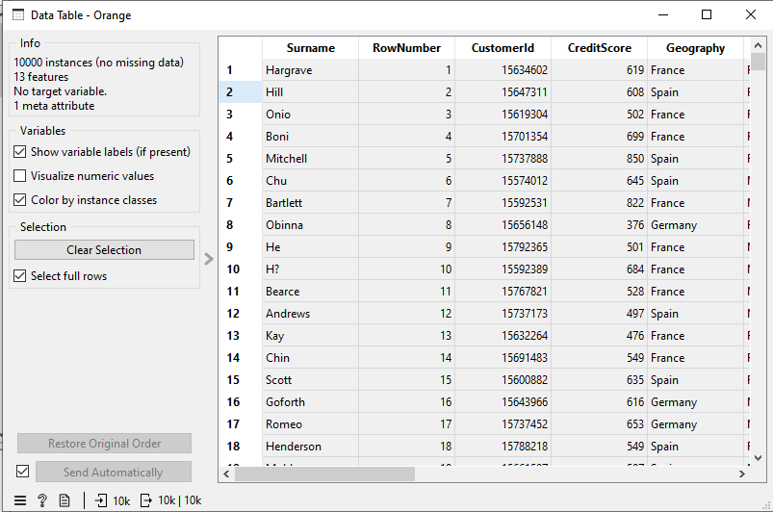
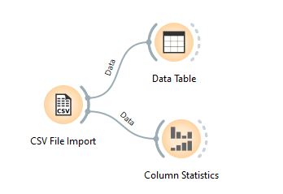

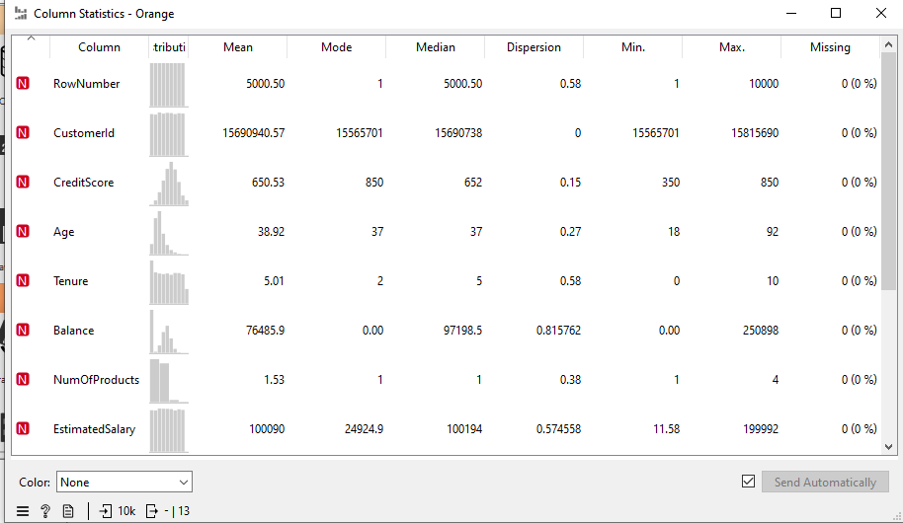

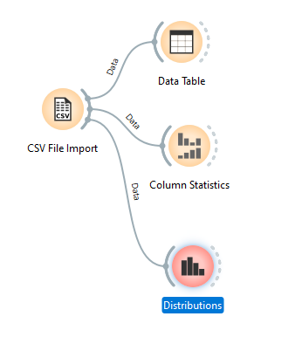
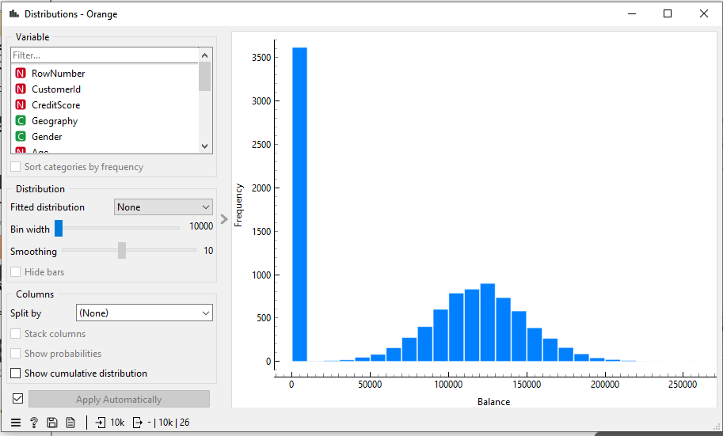
- Data Preparation
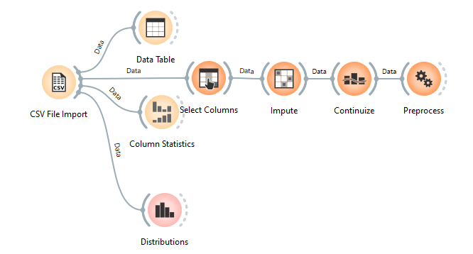

Remove useless columns : use select columns node

Handle missing values : Use Impute

Convert categorical data : Use Continuize

Normalize data : Use preprocess

- Modeling
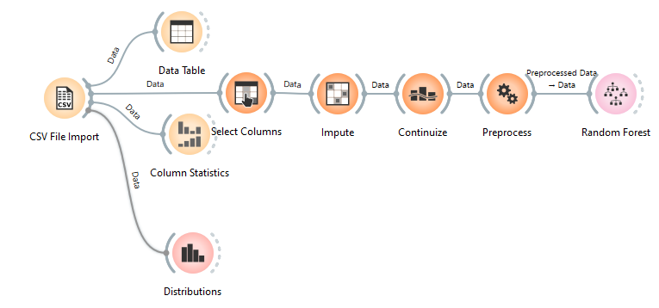
- Evaluation
- Test & Score
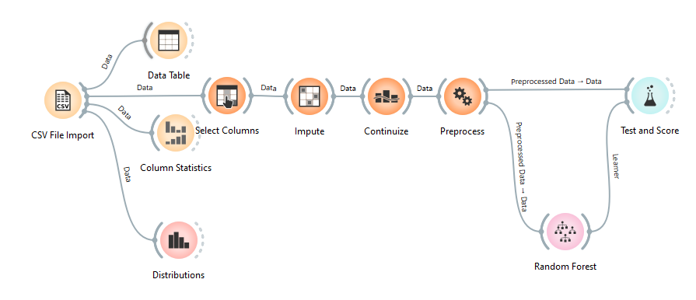
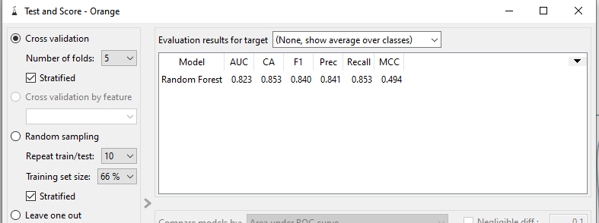

- Confusion Matrix
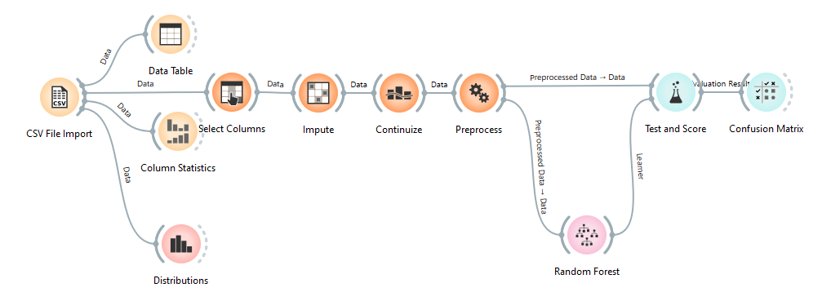

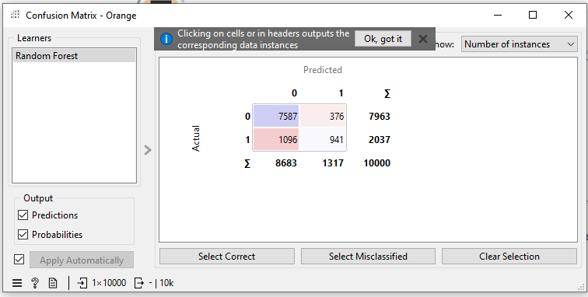

- ROC Analysis
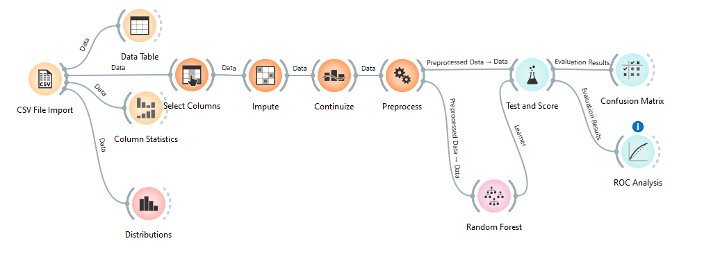
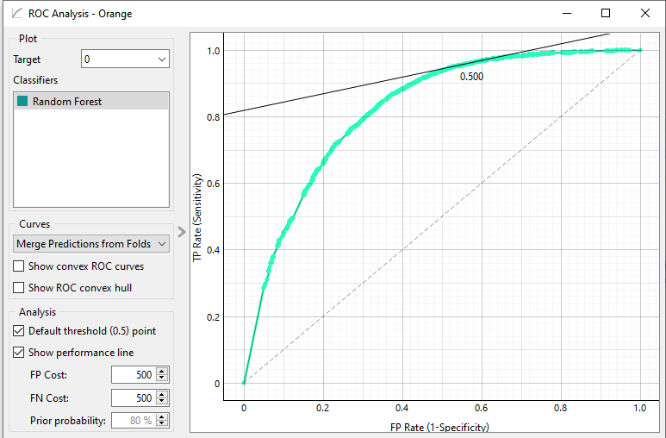

- Deployment
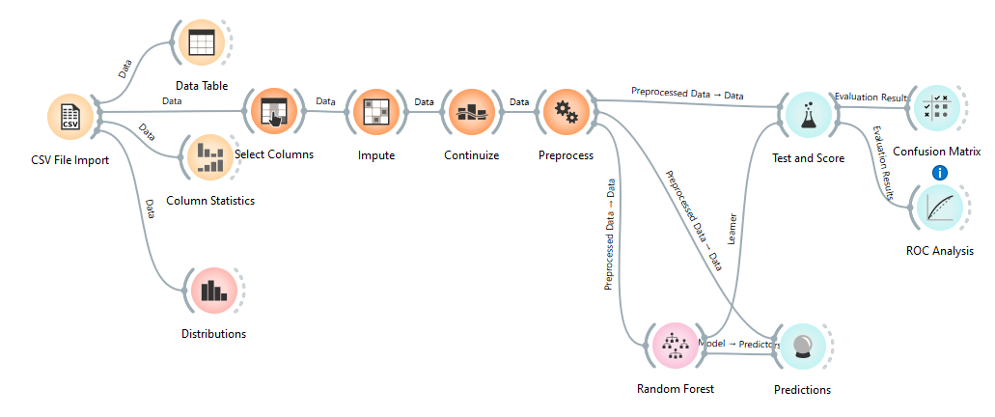
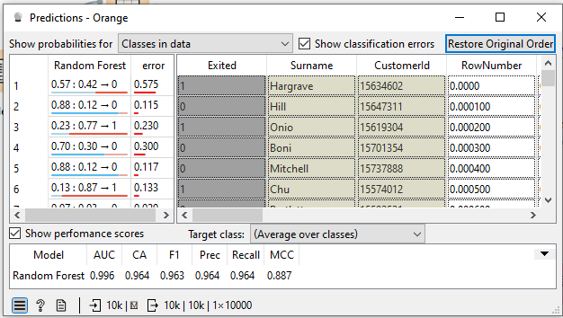

LAB-3
Data Cleaning
Dataset: https://www.kaggle.com/datasets/aranyogeshm/healthcare-dataset

Handling Missing Values
Missing data occurs when no value is stored for a specific attribute in a record. This can happen due to equipment malfunction, human error, or simply because the information was not available at the time of entry.

Removing Duplicates
Duplicate data—where multiple records represent the same real-world entity—can significantly skew statistical analysis and lead to over-represented patterns. This often happens during data integration, where information from multiple databases is merged.

Noise Filtering
Noise refers to a random error or variance in a measured variable. While missing values are "empty," noisy data is "incorrect" or "distorted" (e.g., a person’s age listed as -5 or 200). Noise filtering aims to smooth out these fluctuations to reveal the underlying trend.
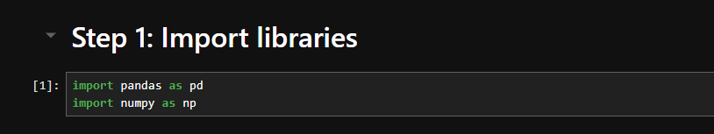
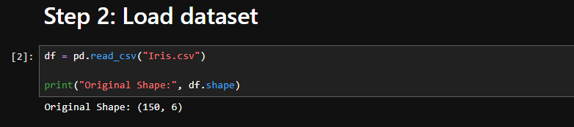
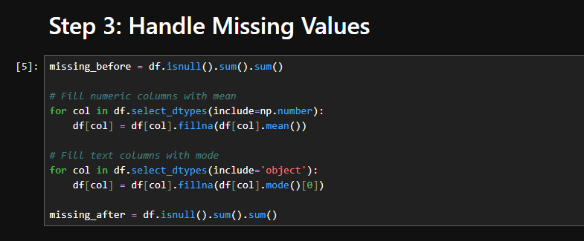
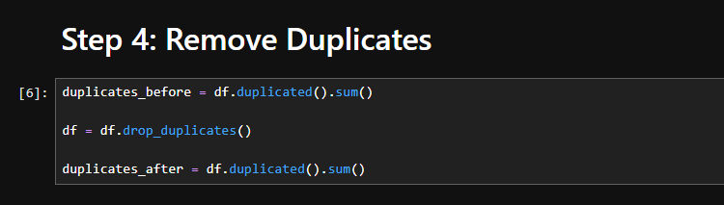
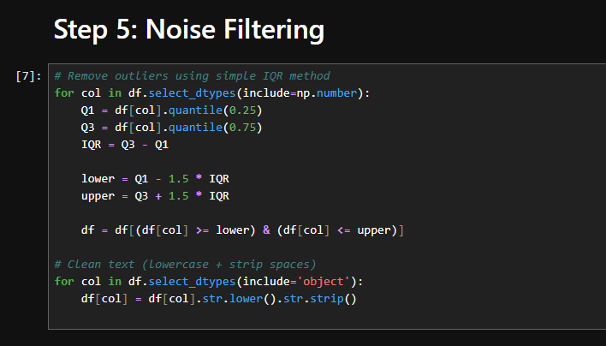
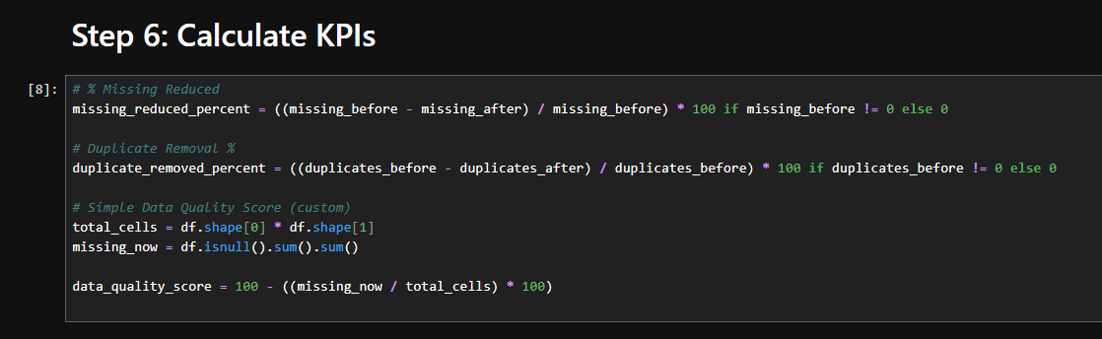
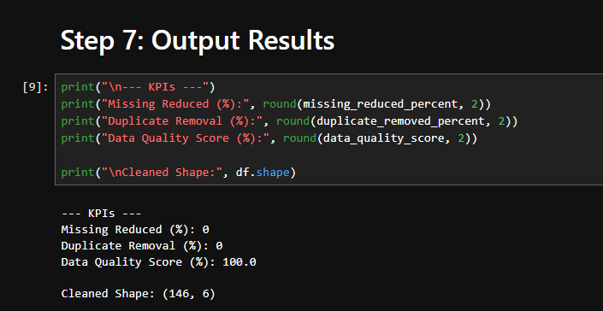

LAB-4
Normalization, standardization, discretization, summary stats

Dataset : https://www.kaggle.com/datasets/mosaadhendam/loan-prediction-dataset

1. Summary Statistics
Summary statistics provide a quick overview of the central tendency, dispersion, and shape of the dataset’s distribution.

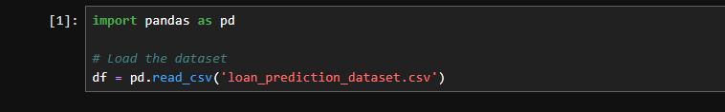
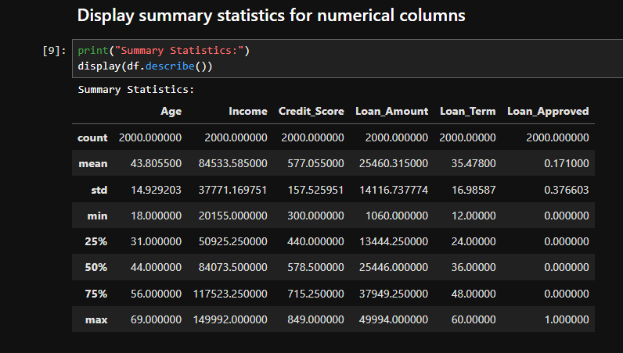

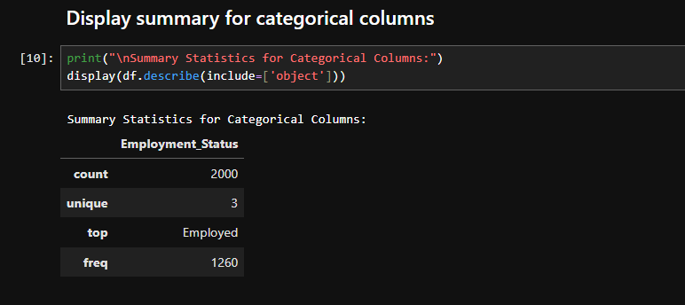

2. Normalization (Min-Max Scaling)
Normalization rescales the data into a specific range, typically $[0, 1]$. This is useful when the features have different scales and the algorithm (like K-NN or Neural Networks) is sensitive to the magnitude of values.
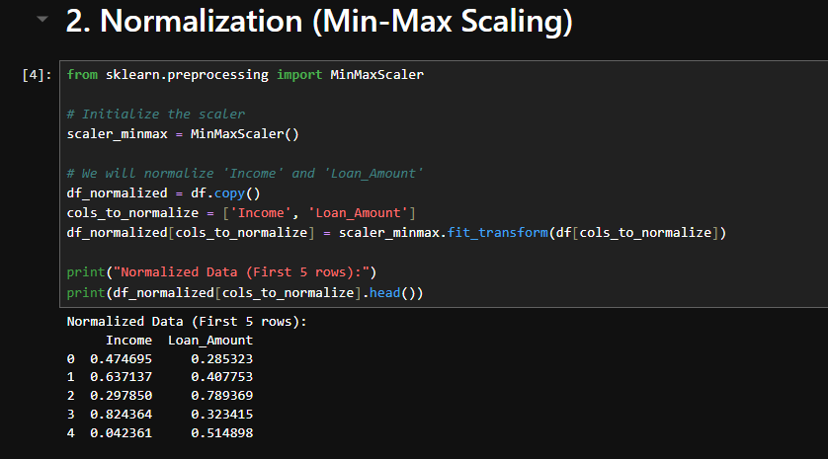

3. Standardization (Z-score Scaling)
Standardization centers the data around a mean of $0$ with a standard deviation of $1$. It is less affected by outliers compared to normalization and is often used for algorithms like Logistic Regression or SVM.
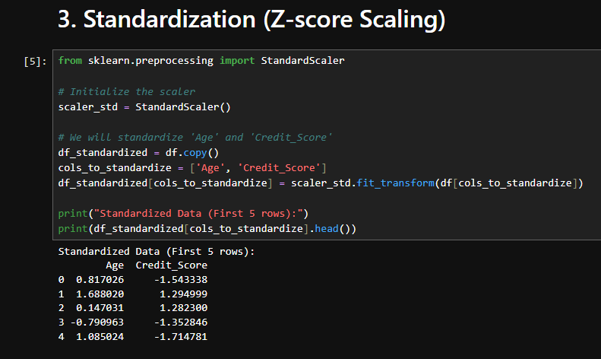

4. Discretization (Binning)
Discretization converts continuous variables into discrete categories (bins). This can help simplify the data or handle non-linear relationships.
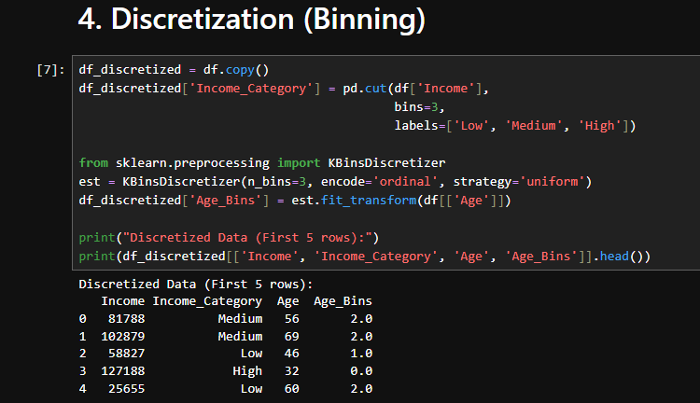

- Load data
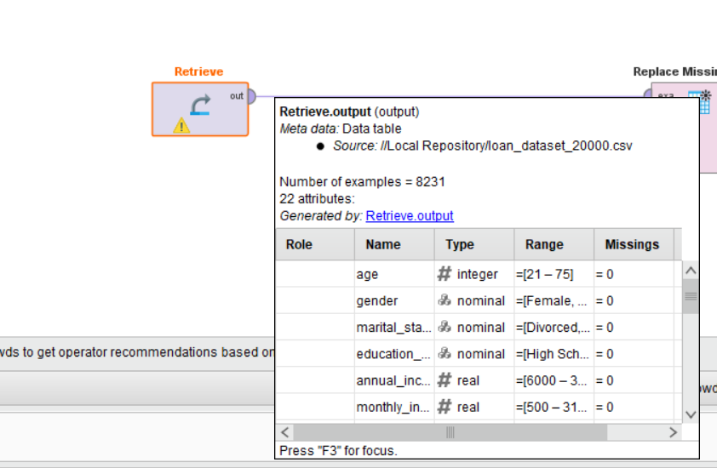

- Handling missing values
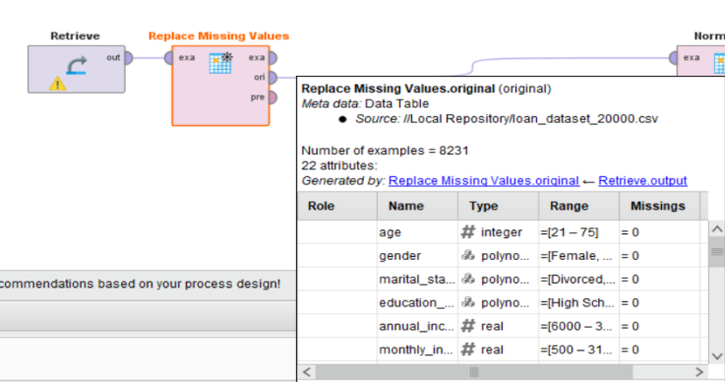

- Normalization
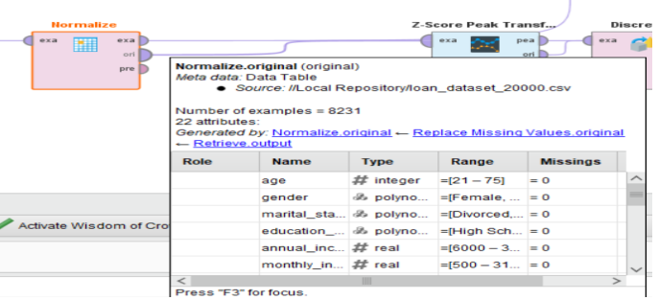

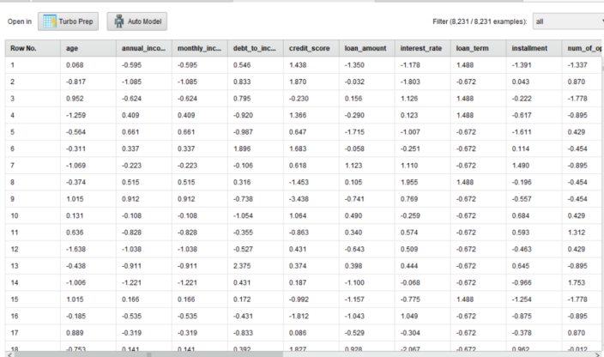

- Z-Score Peak Transformation
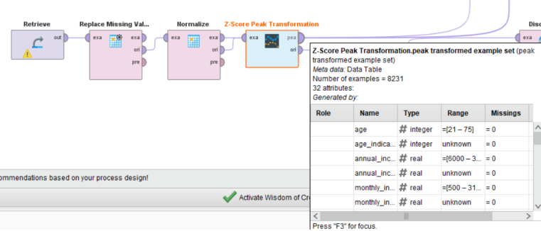
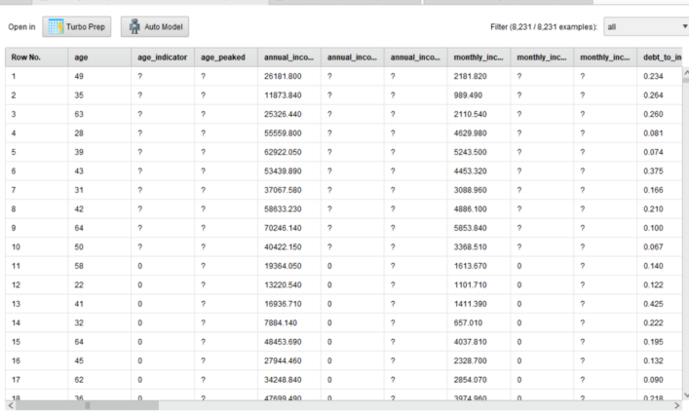
- Discretization
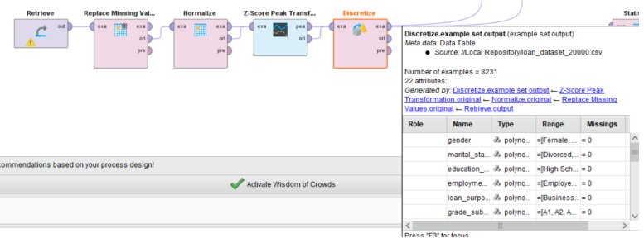

6, statistics
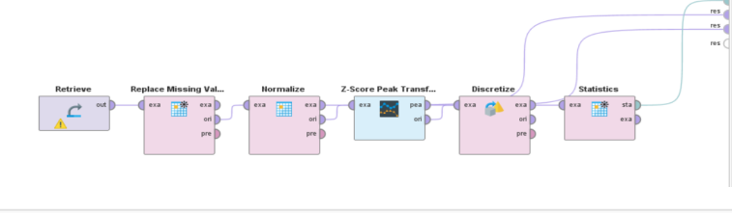
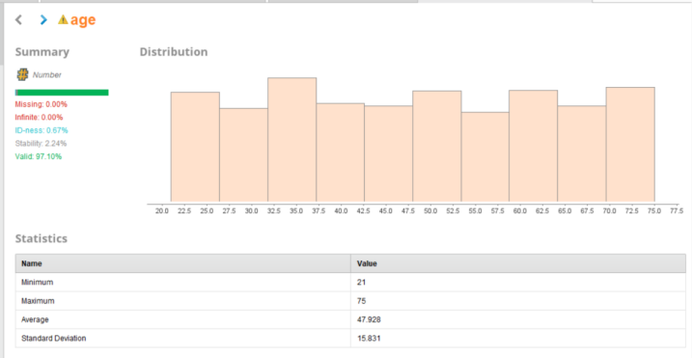

LAB-5
Market basket analysis , Support, confidence, lift calculation manually

Market Basket Analysis (MBA)
Definition:
Market Basket Analysis is a technique in Data Mining used to find relationships between items that customers buy together.

Itemset
A group of items
Example: {Milk, Bread}

Transaction
A single purchase record
Example: T1 = {Milk, Bread, Butter}

1. Support
Definition:
Support shows how frequently an itemset appears in the dataset.
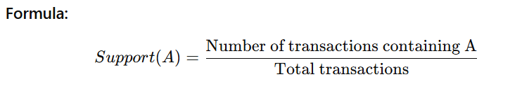

2. Confidence
Definition:
Confidence shows how likely item B is purchased when item A is purchased.
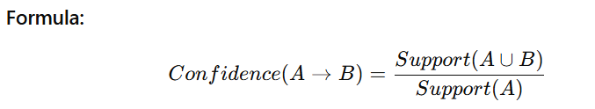

3. Lift
Definition:
Lift tells how strong the relationship is between A and B.
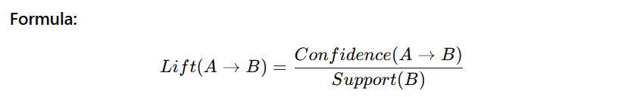
Interpretation:
- Lift = 1 → No relation
- Lift > 1 → Positive relation
- Lift < 1 → Negative relation
Load dataset : https://www.kaggle.com/datasets/janesmile/transaction-data
Preprocessing :
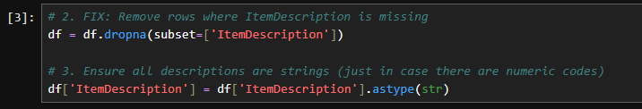
Define items :
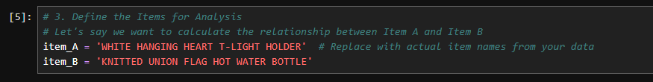
Manual calculations and define transactions :
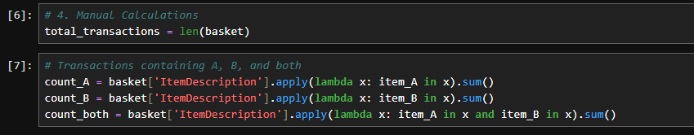
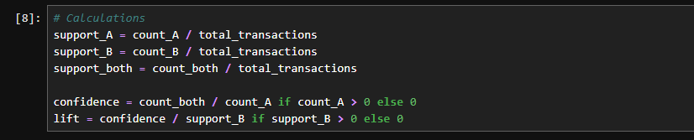
Total transactions :
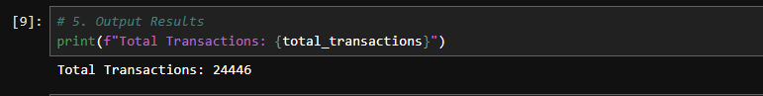
Support :
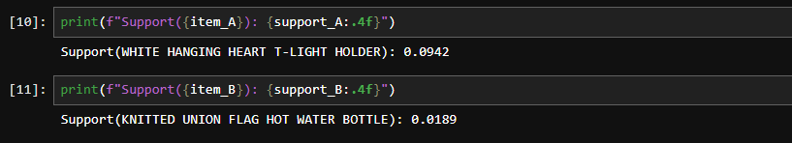
Confidence :
Lift :
Validation :
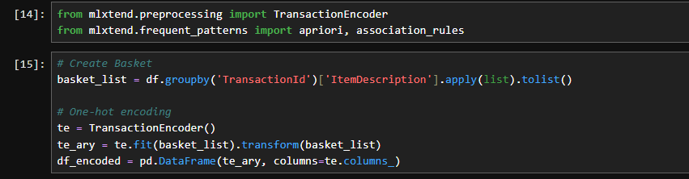

LAB-6
Apriori algorithm using Python, Frequent itemset generation

Apriori Algorithm
Definition:
The Apriori algorithm is a fundamental algorithm in Data Mining used to find frequent itemsets and generate association rules.

1. Itemset
A set of items
Example: {Milk, Bread}

2. Frequent Itemset
An itemset whose support ≥ minimum support threshold
Apriori Property
If an itemset is frequent → all its subsets are also frequent
If an itemset is NOT frequent → all its supersets are NOT frequent

How Apriori Works
- Generate candidate itemsets
- Calculate support
- Remove those below threshold
- Repeat until no more itemsets
Load dataset : DATA MINING\market_basket.csv
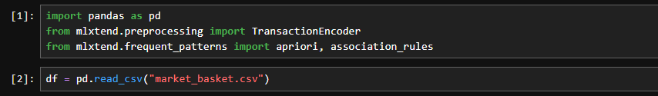
Convert into transactions :
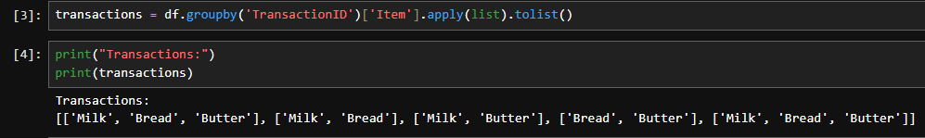
One hot encoding :
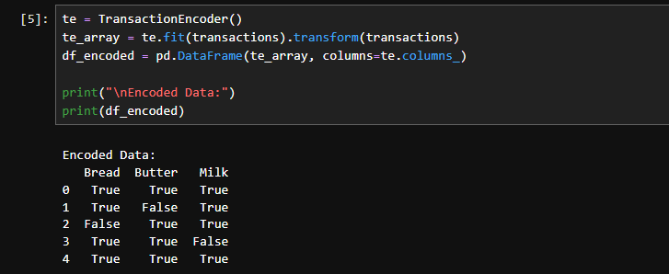
Generate frequent itemset :
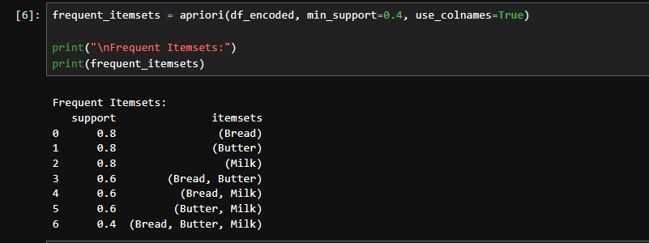
Generate association rules:
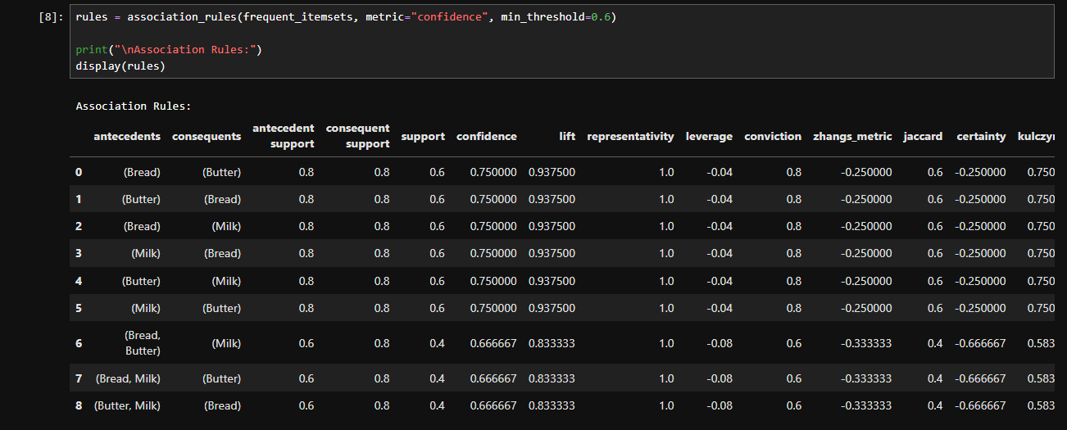

LAB-7
Construct FP-Tree, compare with Apriori

FP-Tree (FP-Growth)
The FP-Growth algorithm is an advanced method in Data Mining used to generate frequent itemsets without candidate generation (unlike Apriori). Instead of generating combinations, it builds a compact tree structure called FP-Tree (Frequent Pattern Tree).

Mining Frequent Patterns from FP-Tree
- Start from least frequent item
- Build conditional pattern base
- Construct conditional FP-tree
- Extract frequent itemsets
No need to generate all combinations

Apriori vs FP-Growth
Feature | Apriori | FP-Growth
Algorithm | Apriori algorithm | FP-Growth algorithm
Candidate Generation | Yes | No
Database Scans | Multiple | No
Speed | Slow | Fast
Memory | High | Efficient
Best For | Small datasets | Large datasets

FP-growth :
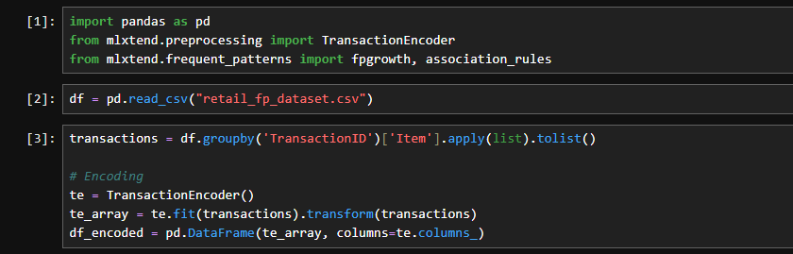
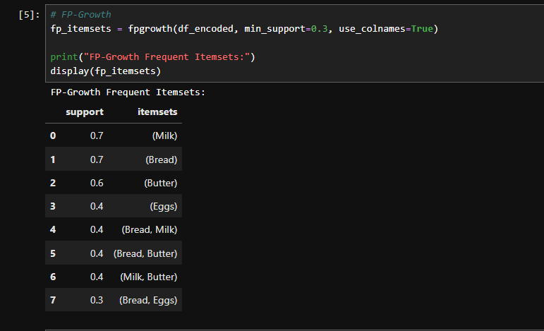
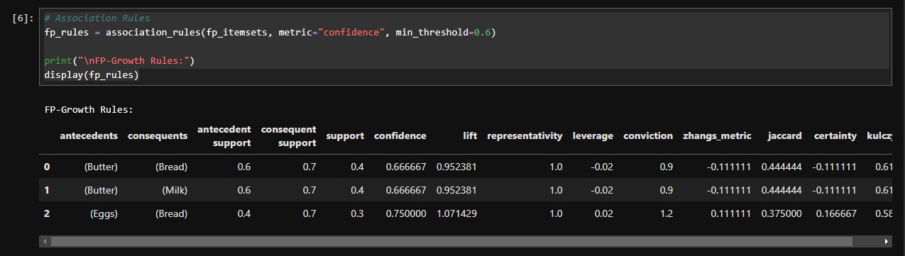
Apriori :
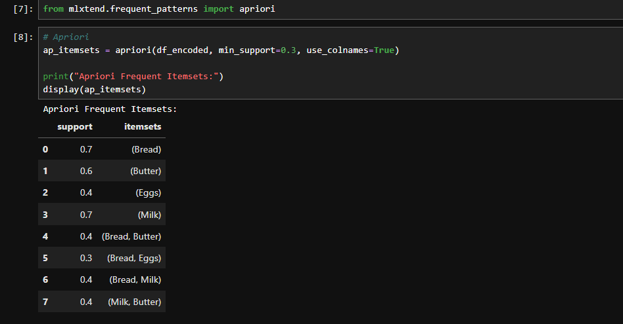
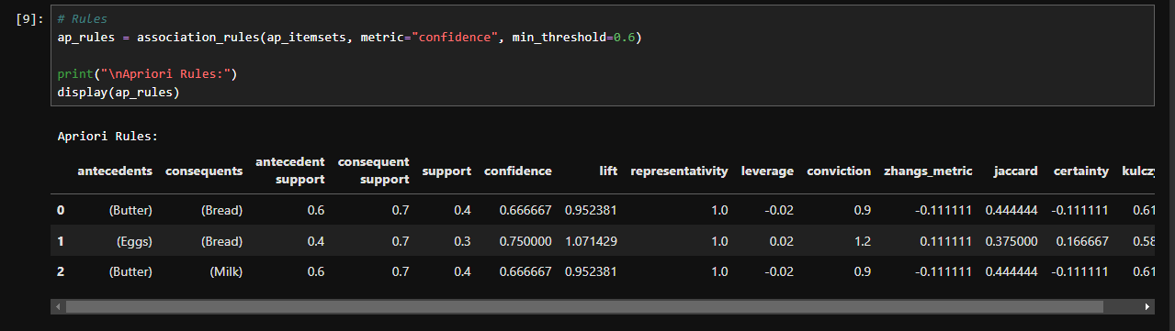
Comparison code :
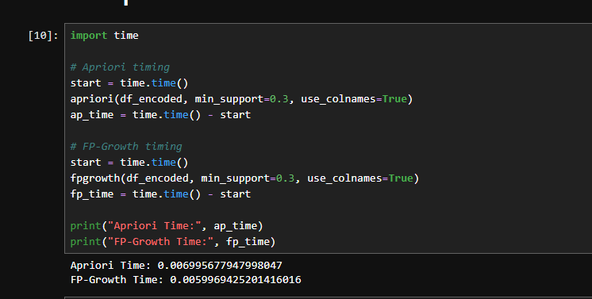

LAB-8
Lists, dictionaries, class creation, preprocessing methods

1. Python Syntax
Python syntax refers to the set of rules that defines how Python programs are written and interpreted. It is designed to be simple and readable, making it beginner-friendly. Python uses indentation instead of brackets to define code blocks such as loops, functions, and conditions.
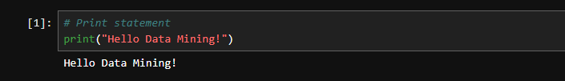
Variables are created by assigning values directly without declaring their type, as Python is a dynamically typed language. Basic syntax includes print statements, input handling, comments, and control structures like if-else and loops. This simplicity makes Python widely used in data science, machine learning, and data mining applications.
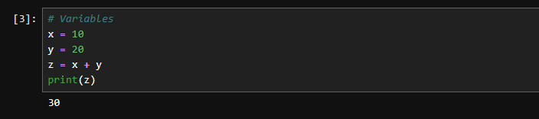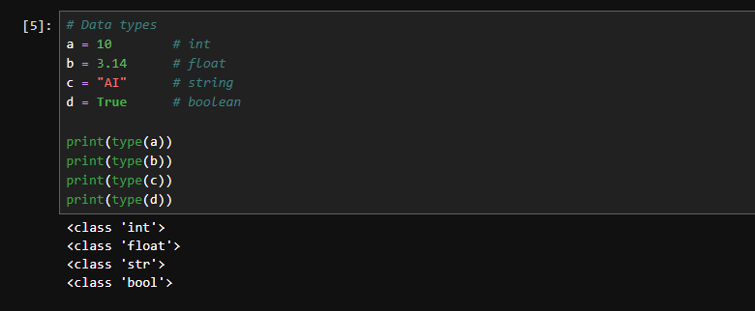

2. Lists in Python
A list in Python is an ordered, mutable (changeable) collection that can store multiple values in a single variable. Lists can contain elements of different data types such as integers, strings, or even other lists. Each element in a list is indexed starting from zero, which allows easy access and modification. Lists are very useful in data mining because they help store and manipulate datasets, transaction records, and feature values. Common operations on lists include adding elements, removing elements, slicing, and iterating through items using loops.
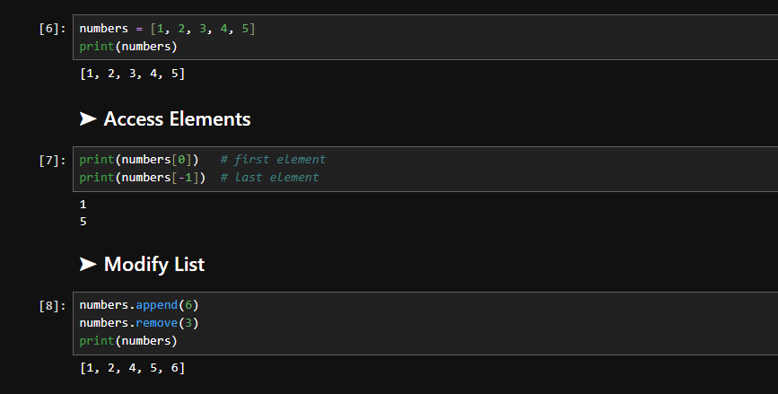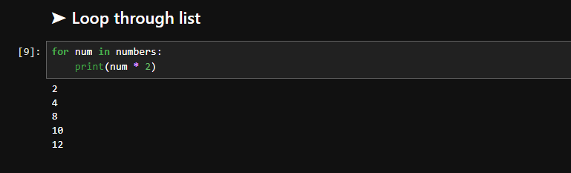

3. Dictionaries in Python
A dictionary in Python is an unordered collection of data stored in key-value pairs. Each key is unique and is used to access its corresponding value. Dictionaries are highly efficient for searching and retrieving data because they use a hashing mechanism. They are widely used in data mining to represent structured data such as records, datasets, and feature mappings.
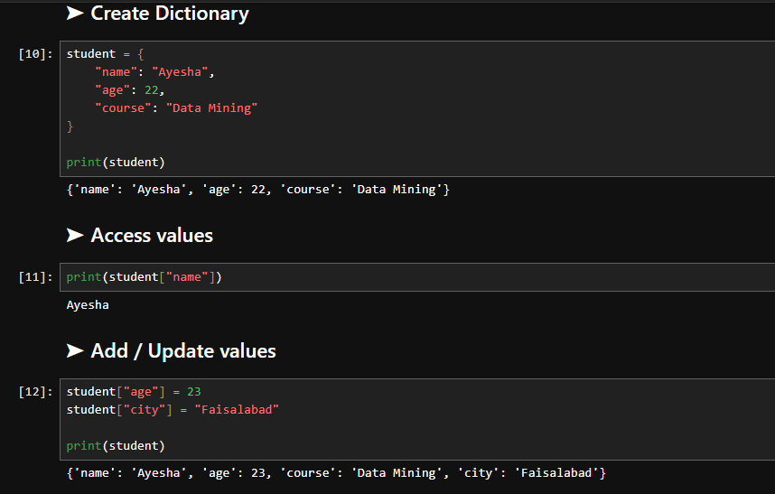
For example, a student record can be stored using keys like name, age, and course. Dictionaries support operations such as adding, updating, and deleting key-value pairs.
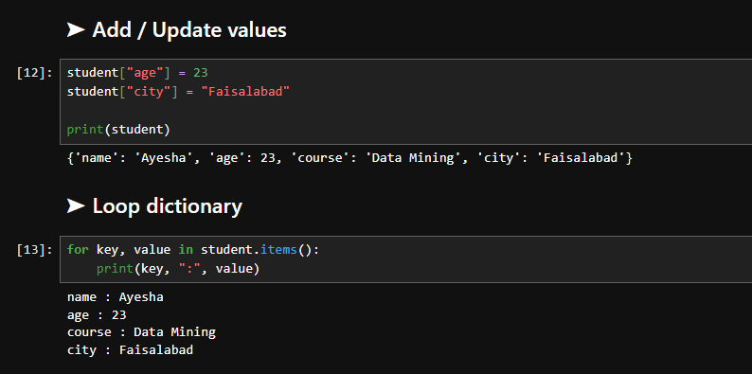

4. OOP Basics
Object-Oriented Programming (OOP) is a programming paradigm based on the concept of objects and classes. A class is a blueprint that defines properties (attributes) and behaviors (methods), while an object is an instance of a class. OOP helps in organizing code in a modular and reusable way. It includes key concepts such as encapsulation, inheritance, polymorphism, and abstraction. In data mining and machine learning, OOP is used to structure preprocessing pipelines, model building, and reusable components for better code management and scalability.

Class Creation in Python
In Python, a class is created using the class keyword and is used to define a structure that combines data and functions. The constructor method __init__ is automatically called when an object is created and is used to initialize variables. Methods inside a class define the behavior of objects. Class creation allows developers to group related functions and data together, making programs more organized and reusable. In data mining, classes are often used to build preprocessing tools, custom algorithms, and machine learning pipelines.
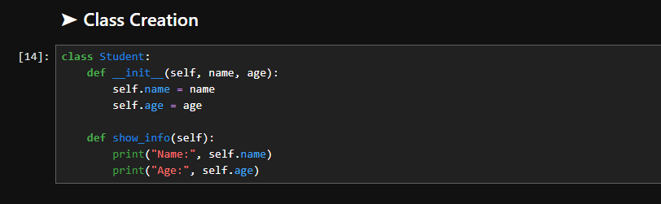
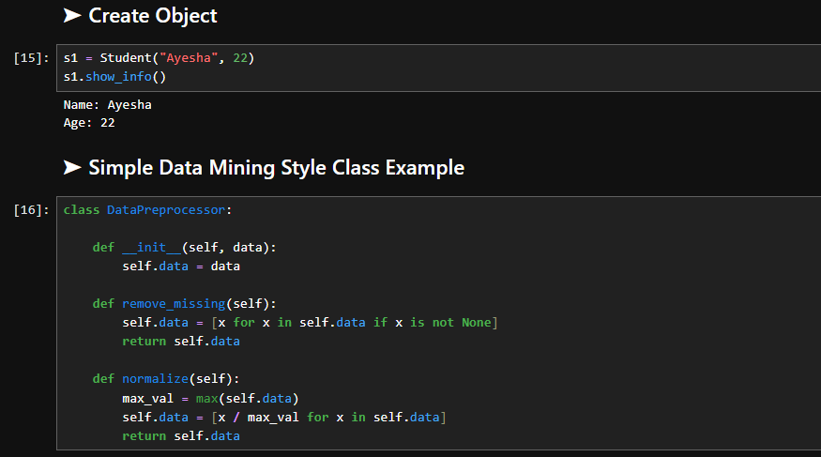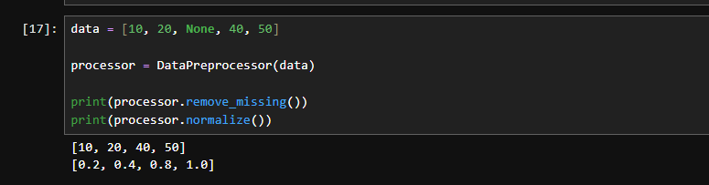

6. Preprocessing Methods in Data Mining
Data preprocessing is an essential step in data mining that involves cleaning and transforming raw data into a suitable format for analysis. Real-world data often contains missing values, noise, inconsistencies, and outliers, which must be handled before applying machine learning algorithms. Common preprocessing techniques include handling missing values using mean, median, or mode; encoding categorical variables into numerical form; scaling features using normalization or standardization; and removing duplicates or outliers. Preprocessing improves data quality, increases model accuracy, and ensures better performance of data mining algorithms.
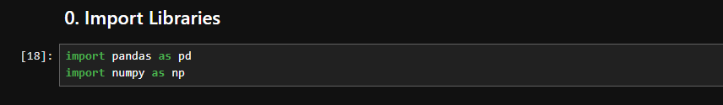
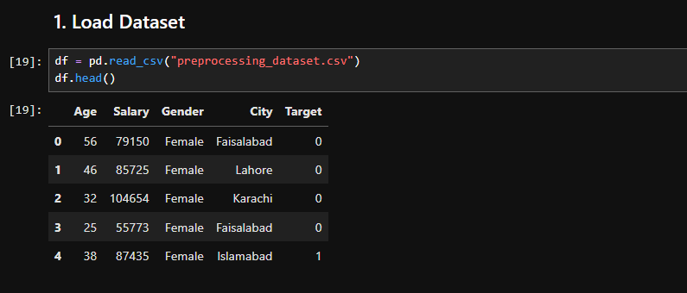
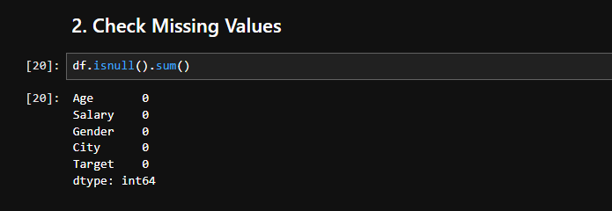
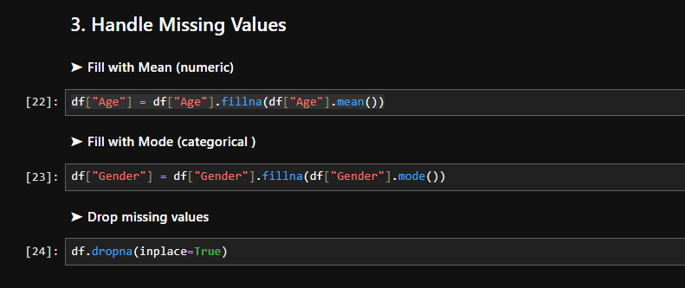
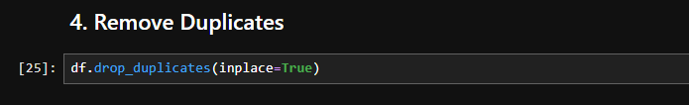
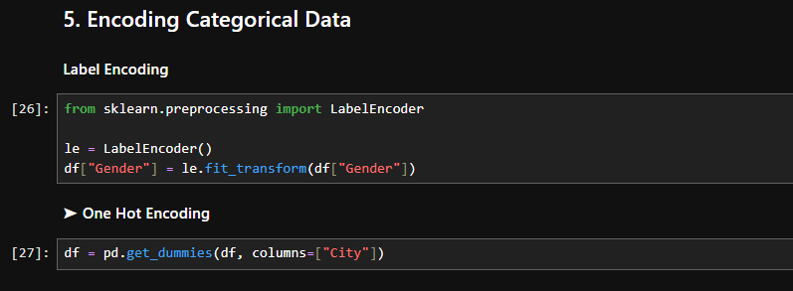
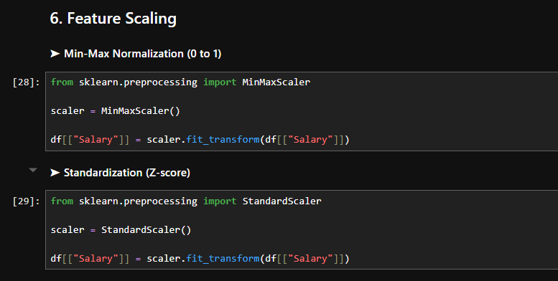
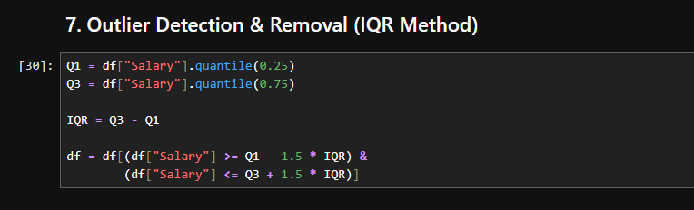
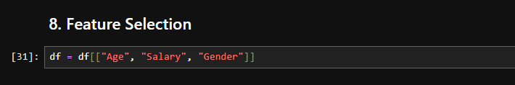
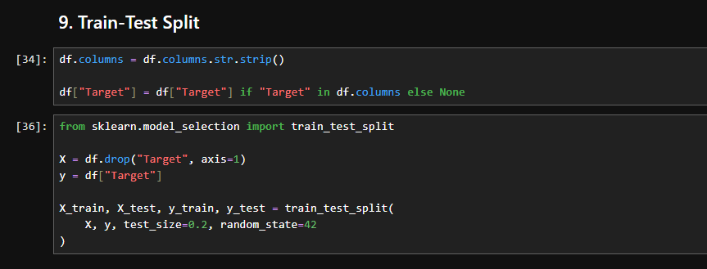
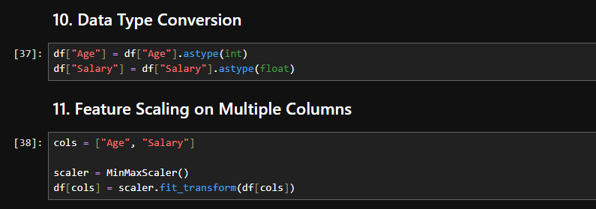
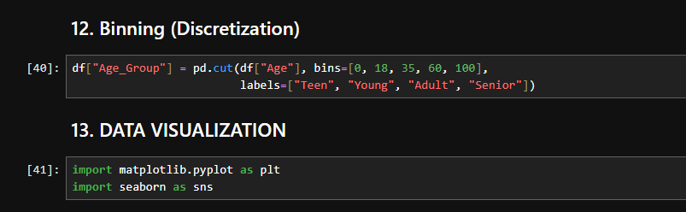
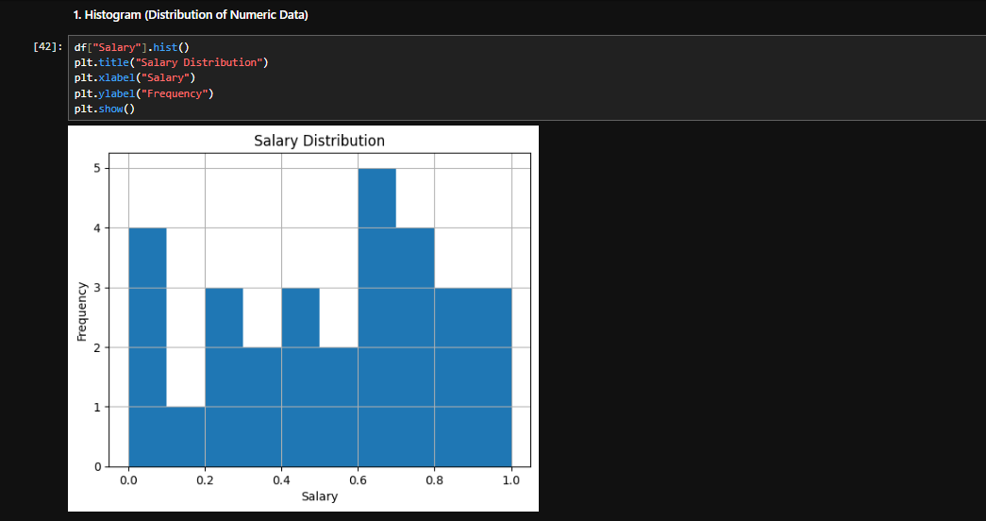
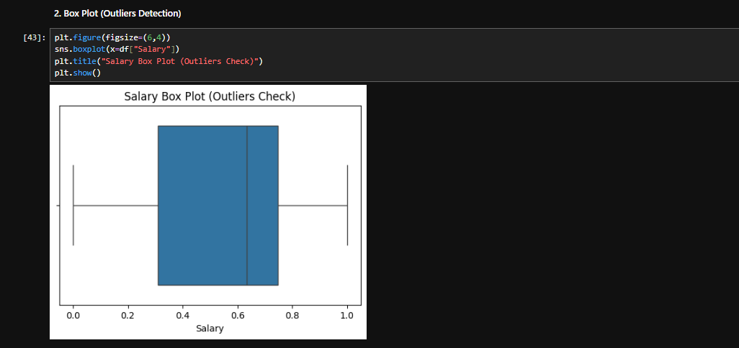
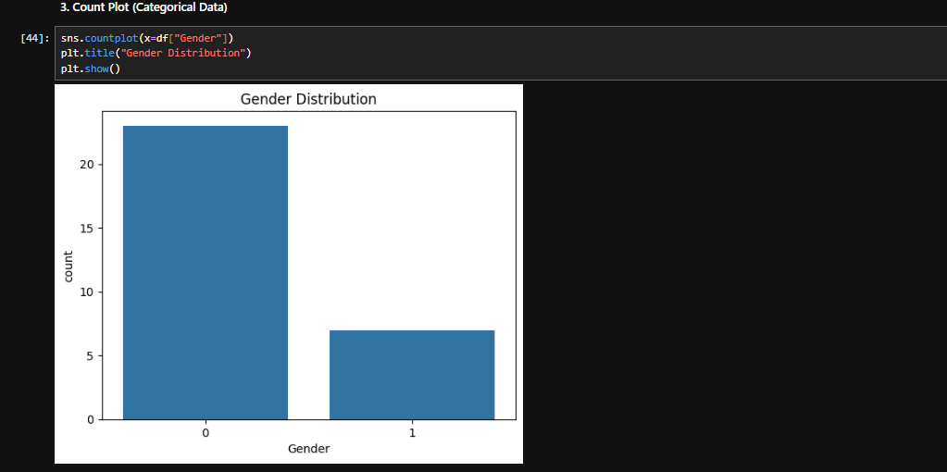
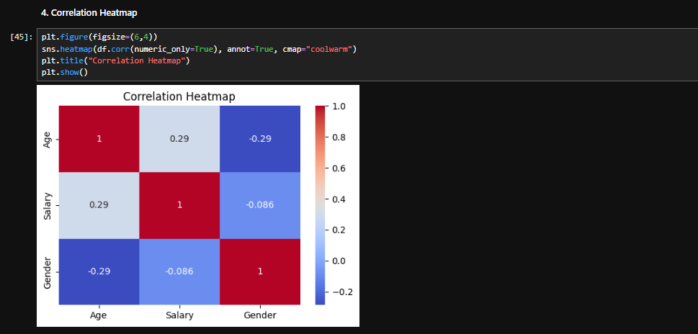
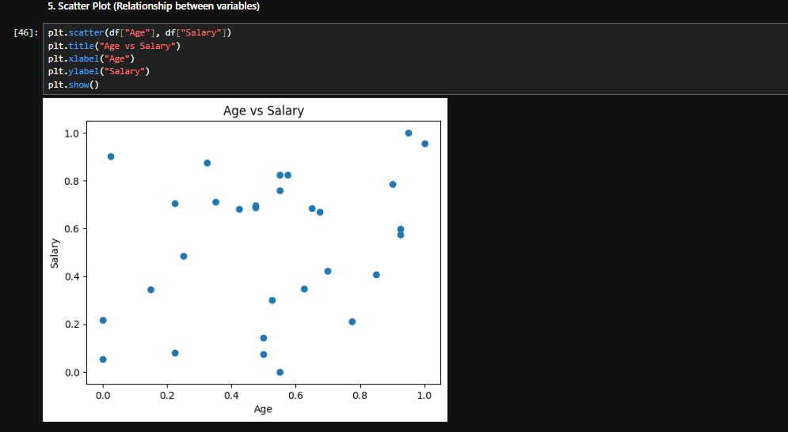
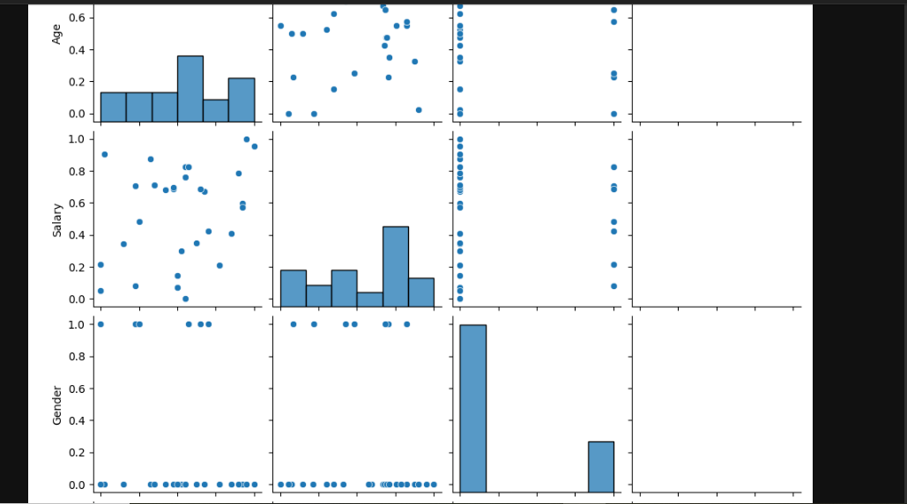

LAB-9

Decision Tree Classifier for Customer Purchase Prediction

Lab Title
Building a Decision Tree Classifier for Customer Purchase Prediction

Theory

Decision Tree Classifier
A Decision Tree is a supervised machine learning algorithm used for classification and regression tasks. It predicts the target variable by learning simple decision rules inferred from the training data.
The model creates a tree-like structure consisting of:

1. Root Node
Represents the most important feature used for splitting the data.

2. Internal Nodes
Represent conditions or tests on features.

3. Leaf Nodes
Represent the final prediction or class label.

How Decision Trees Work
- Start with the complete dataset.
- Select the best feature for splitting using criteria such as:
- Gini Index or Entropy (Information Gain)
- Divide the dataset into subsets.
- Repeat the process recursively until:
- Maximum depth is reached, or
- Nodes become pure.

Advantages
- Easy to understand and interpret.
- Requires little data preprocessing.
- Handles both numerical and categorical data.
- Visualization is straightforward.

Disadvantages
- Can easily overfit the data.
- Sensitive to small changes in data.
- May create biased trees if classes are imbalanced.

Dataset
Use the Customer Personality Analysis Dataset available on Kaggle.

Dataset Link:
Customer Personality Analysis Dataset
This dataset contains customer demographics and purchasing behavior useful for marketing analysis.

Jupyter Notebook Code

Step 1: Import Libraries
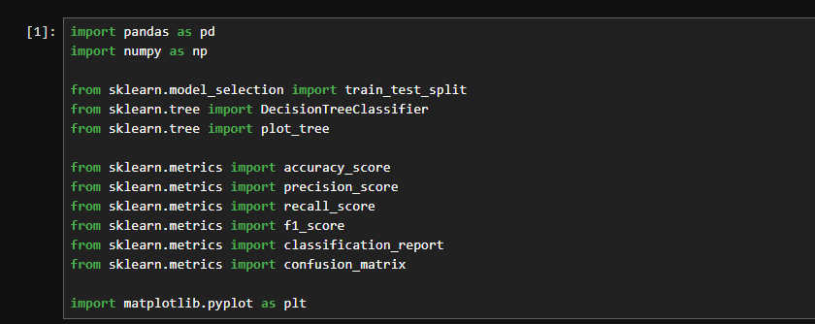

Step 2: Load Dataset
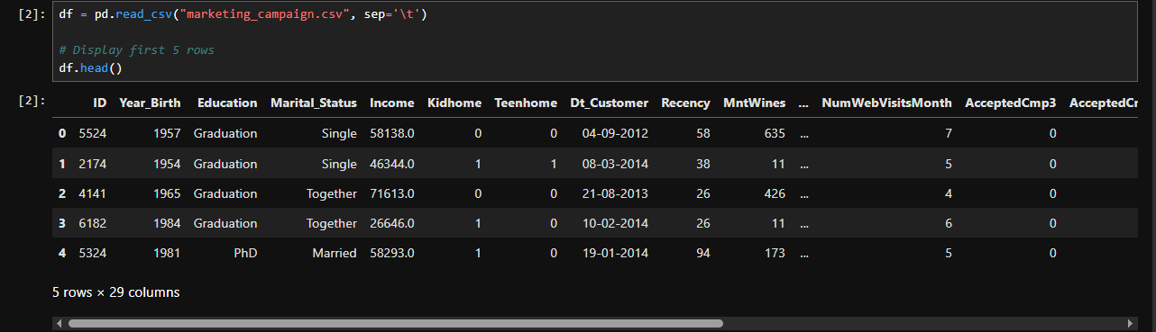

Step 3: Check Dataset Information
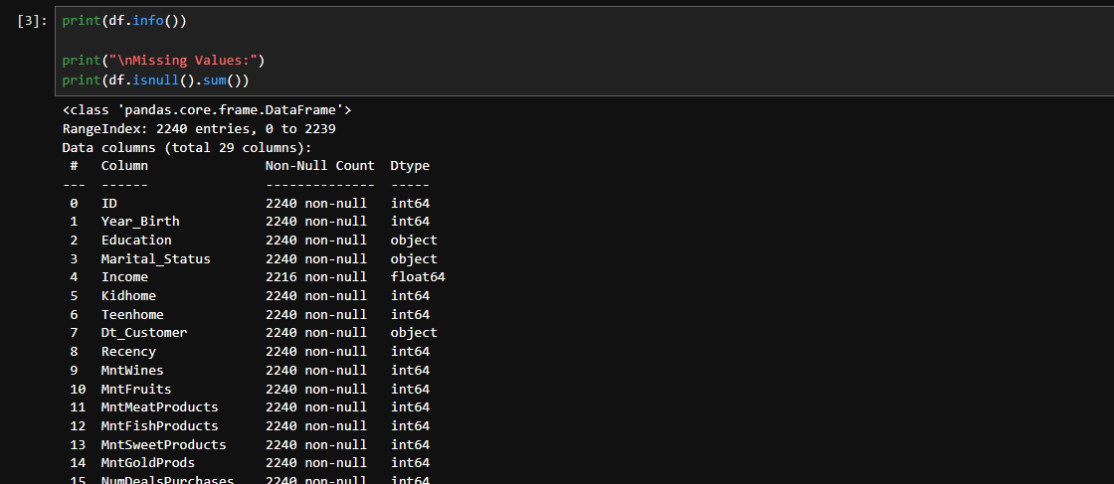

Step 4: Data Preprocessing

Remove unnecessary columns
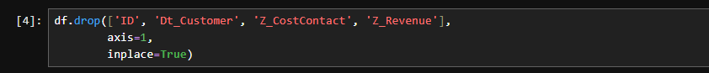

Handle Missing Values

Convert Categorical Variables into Numeric
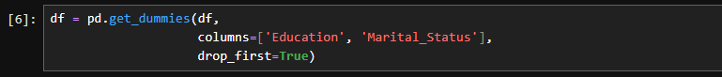

Step 5: Define Features and Target Variable
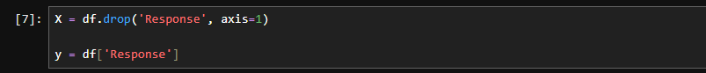

Step 6: Split Dataset into Training and Testing Sets
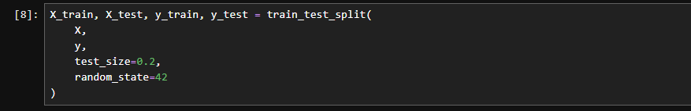

Step 7: Build Decision Tree Classifier
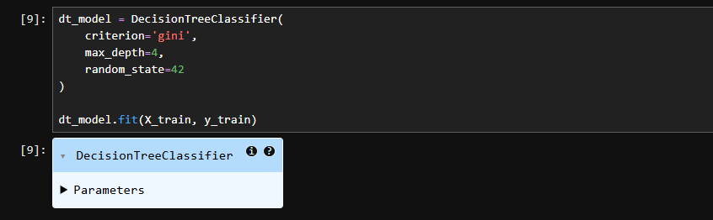

Step 8: Make Predictions

Step 9: Visualize the Decision Tree
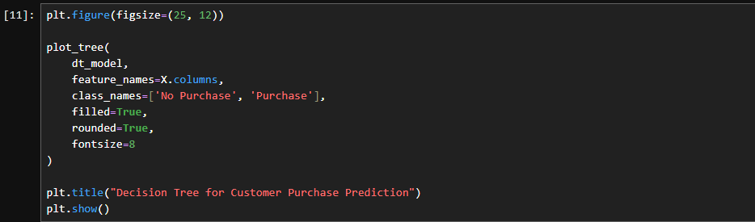
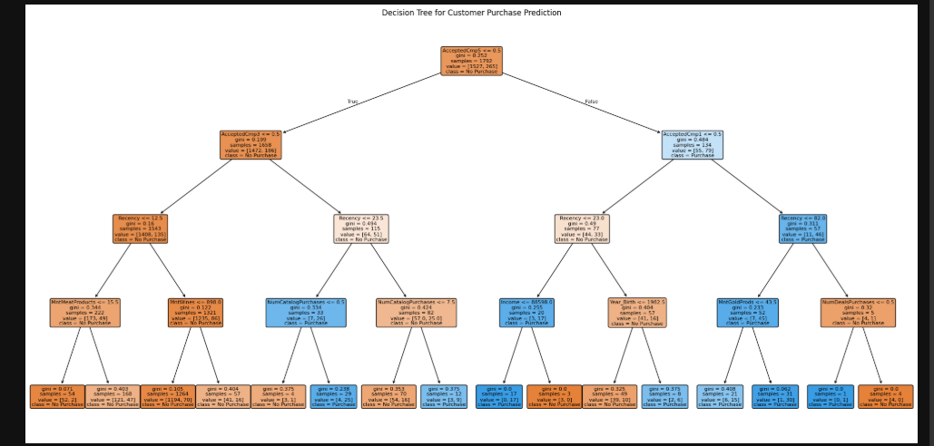

Step 10: Evaluate Model Performance

Accuracy
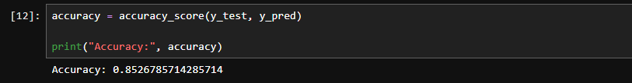

Precision
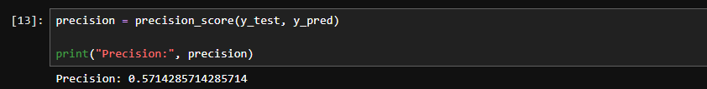

Recall
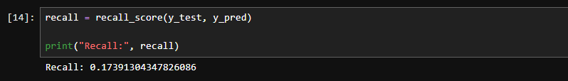

F1-Score
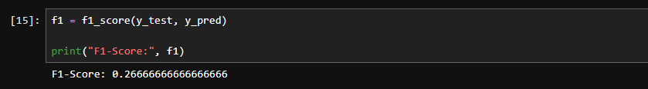

Step 11: Classification Report
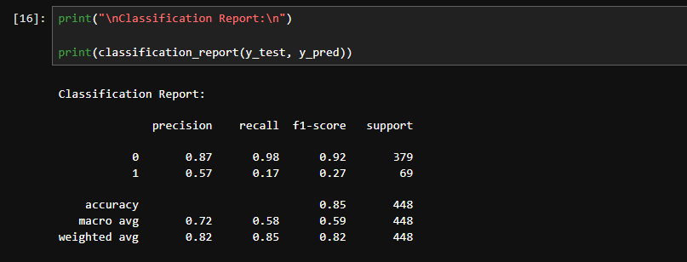

Step 12: Confusion Matrix
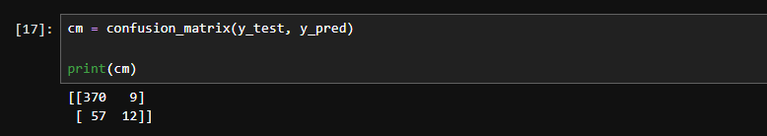

LAB-10

Email Spam Detection using Naïve Bayes and K-Nearest Neighbors (KNN)

Lab Title
Implementation of Naïve Bayes and KNN Algorithms for Email Spam Detection and Comparison of Results

Theory

1. Naïve Bayes Classifier
Naïve Bayes is a probabilistic supervised learning algorithm based on Bayes' Theorem. It assumes that all features are independent of each other, which is why it is called "naïve."

Bayes' Theorem
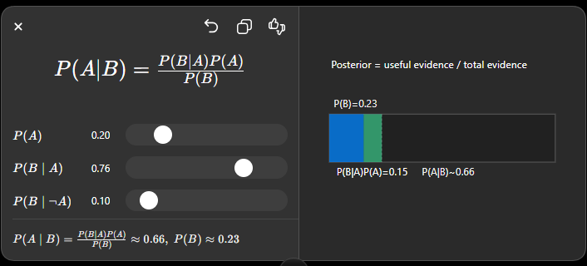
Where:
- P(A|B) = Posterior probability
- P(B|A) = Likelihood
- P(A) = Prior probability
- P(B) = Evidence probability

2. K-Nearest Neighbors (KNN)
KNN is a supervised machine learning algorithm that classifies data based on the majority class among its K nearest neighbors.

Working of KNN
- Choose the value of K.
- Calculate the distance between the new data point and all training points.
- Select the K nearest neighbors.
- Assign the class with the majority vote.

Dataset
Use the SMS Spam Collection Dataset (commonly used for email/spam detection studies).

Dataset Link:
SMS Spam Collection Dataset (Kaggle)

Jupyter Notebook Code

Step 1: Import Libraries
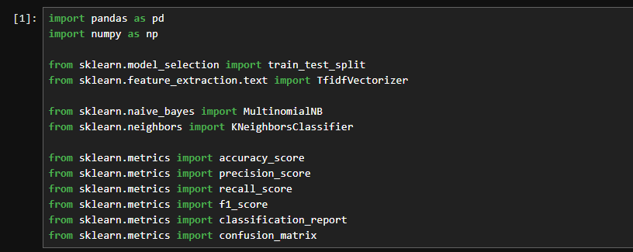

Step 2: Load Dataset

Step 3: Display Dataset Information
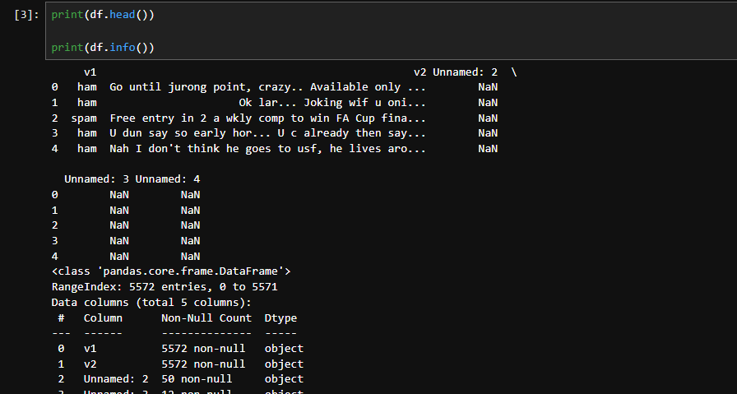

Step 4: Data Preprocessing
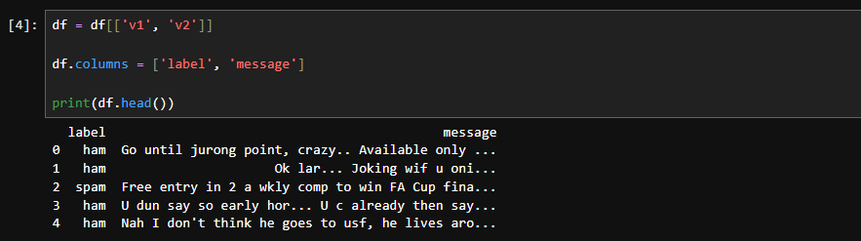

Step 5: Convert Labels into Numeric Form
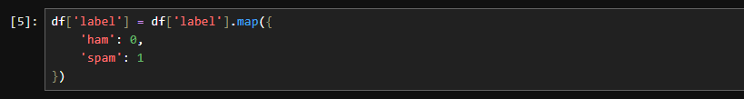

Step 6: Define Features and Target Variable
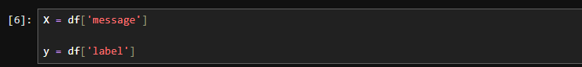

Step 7: Convert Text into Numerical Features using TF-IDF
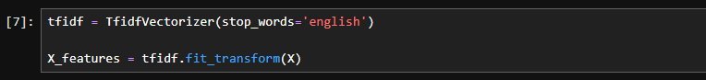

Step 8: Split Dataset
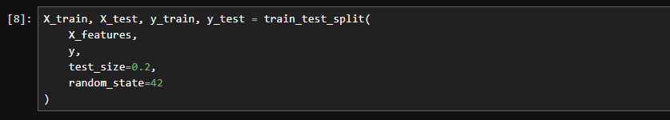

Part A: Naïve Bayes Implementation

Step 9: Train Naïve Bayes Model
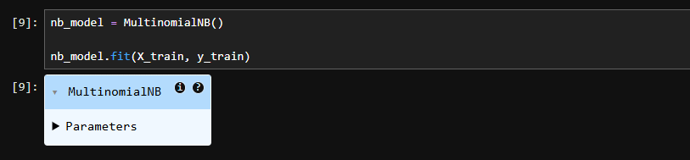

Step 10: Make Predictions

Step 11: Evaluate Naïve Bayes Model
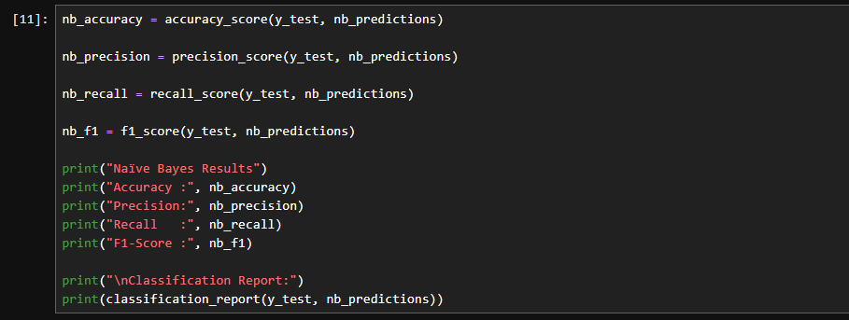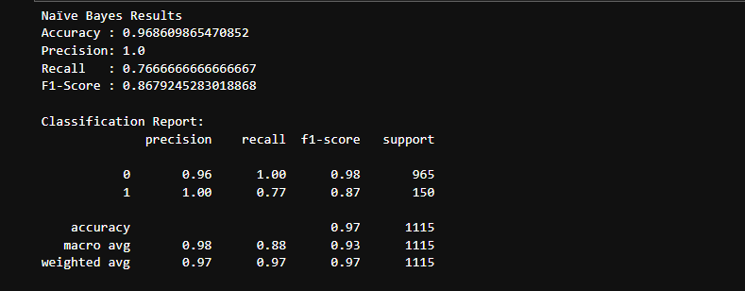

Part B: KNN Implementation

Step 12: Train KNN Model
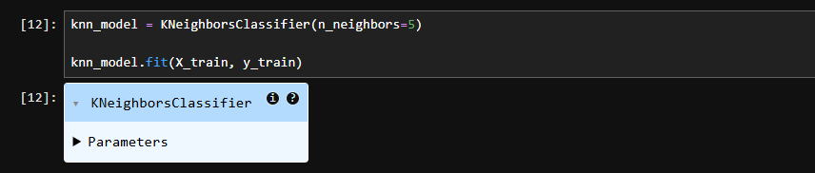

Step 13: Make Predictions

Step 14: Evaluate KNN Model
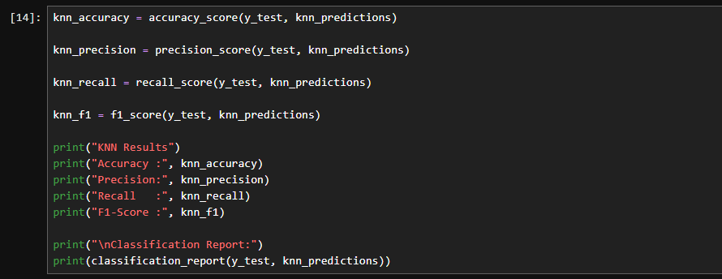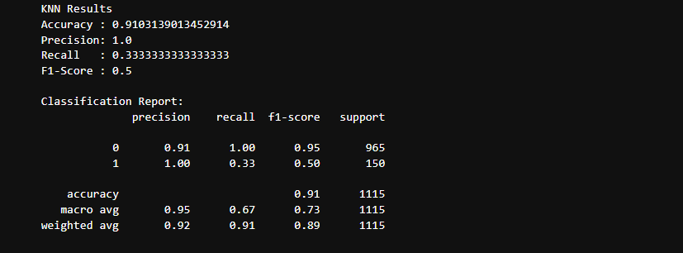

Comparison of Results

Step 15: Compare Both Models
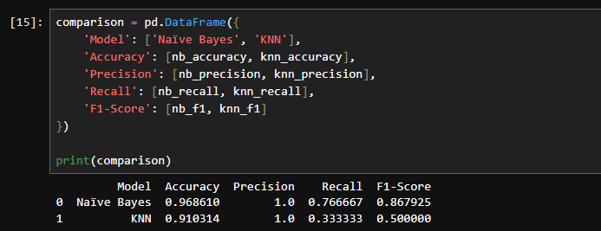

Step 16: Visual Comparison
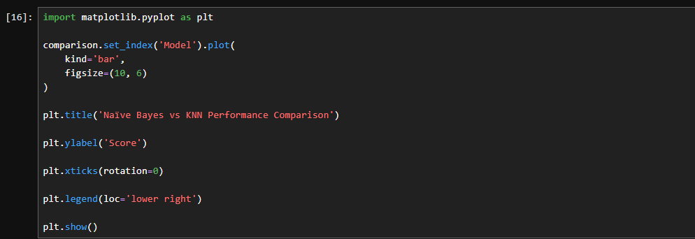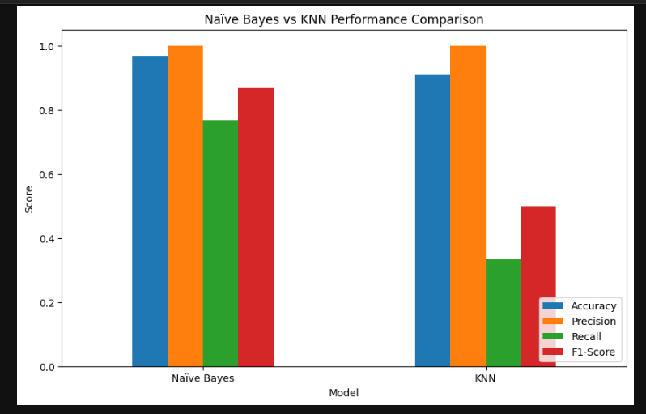
LAB-11

Credit Card Fraud Detection using Support Vector Machine (SVM)

Lab Title
Implementation of Support Vector Machine (Linear & RBF Kernel) for Credit Card Fraud Detection and Model Evaluation

Theory

Support Vector Machine (SVM)
Support Vector Machine (SVM) is a supervised machine learning algorithm used for classification and regression problems. It aims to find the optimal hyperplane that separates different classes with the maximum margin.

Key Concepts in SVM

1. Hyperplane
A hyperplane is a decision boundary that separates different classes.
For two-dimensional data:
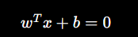
Where:
- w = Weight vector
- x = Feature vector
- b = Bias term

2. Support Vectors
Support vectors are the data points closest to the hyperplane. These points determine the position and orientation of the decision boundary.

3. Margin
Margin is the distance between the hyperplane and the nearest data points from each class.
SVM tries to maximize this margin to improve generalization.

Kernel Concepts
Sometimes data is not linearly separable. Kernels transform the data into higher-dimensional spaces where separation becomes easier.

1. Linear Kernel
Used when data is approximately linearly separable.
Formula:
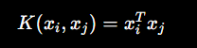

2. Radial Basis Function (RBF) Kernel
The RBF kernel maps data into a higher-dimensional space to handle nonlinear relationships.
Formula:
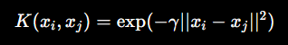
Where:
- γ (gamma) controls the influence of a single training example.

Dataset
Use the Credit Card Fraud Detection Dataset available on Kaggle.

Dataset Link:
Credit Card Fraud Detection Dataset
This dataset contains transactions made by European credit card holders.

Jupyter Notebook Code

Step 1: Import Libraries
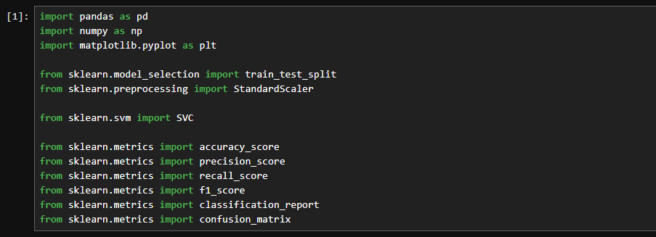

Step 2: Load Dataset
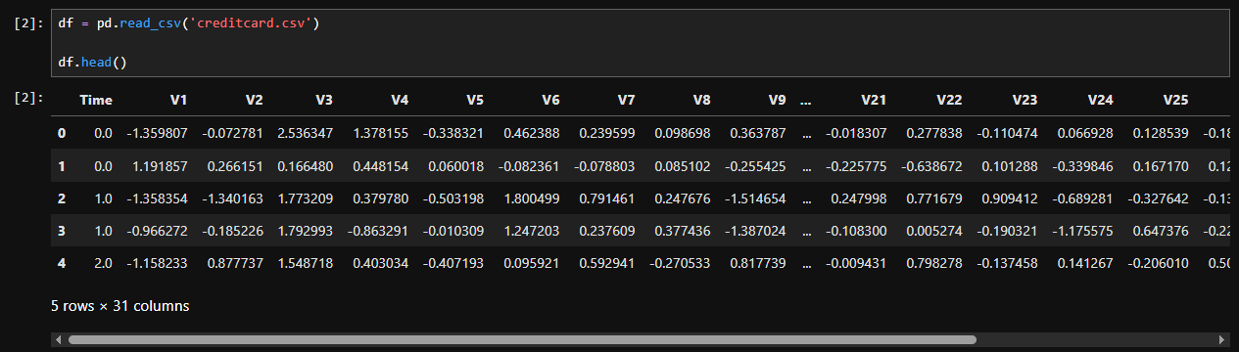

Step 3: Explore Dataset
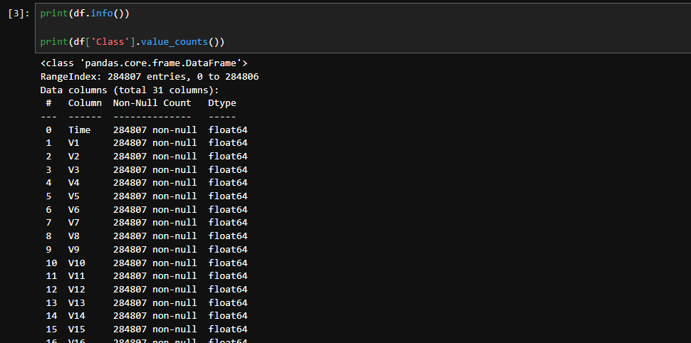

Step 4: Handle Class Imbalance
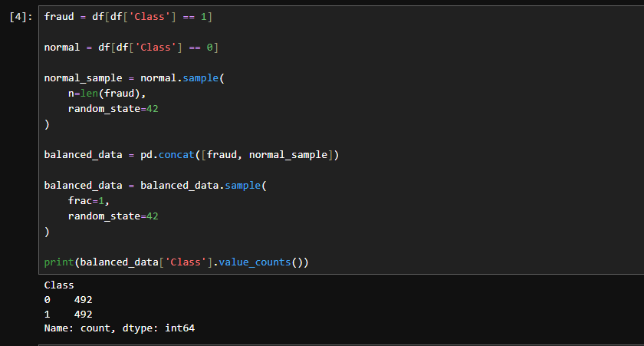

Step 5: Define Features and Target Variable
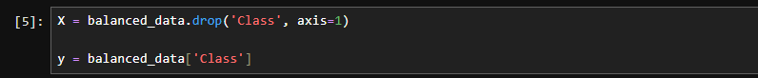

Step 6: Split Dataset
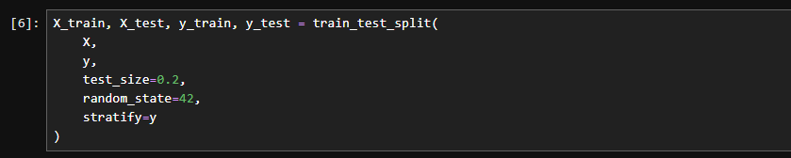

Step 7: Feature Scaling
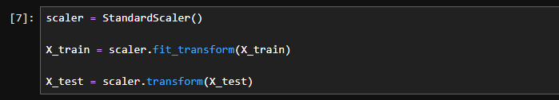

Part A: SVM with Linear Kernel

Step 8: Train Linear SVM
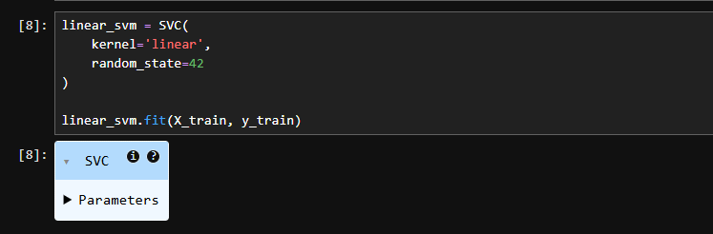

Step 9: Predictions

Step 10: Evaluate Linear SVM
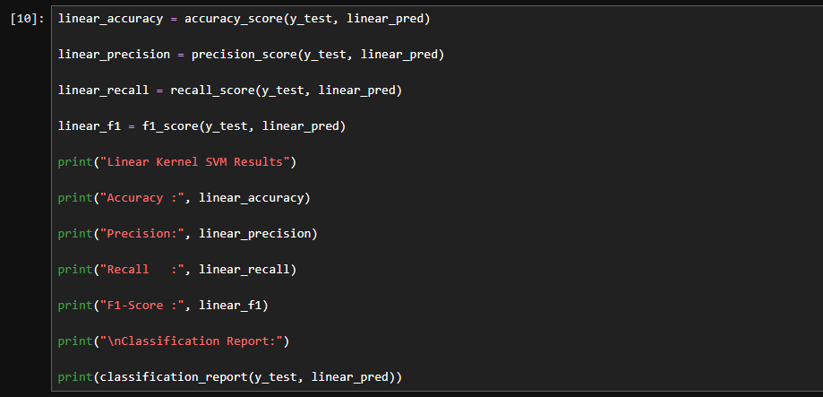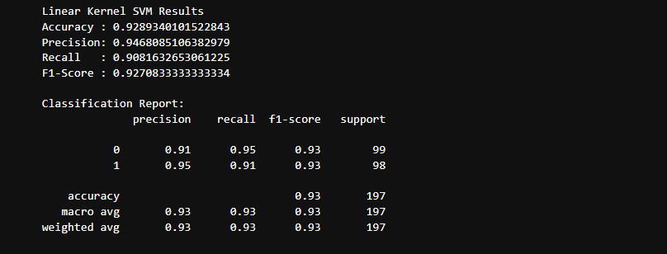

Part B: SVM with RBF Kernel

Step 11: Train RBF SVM
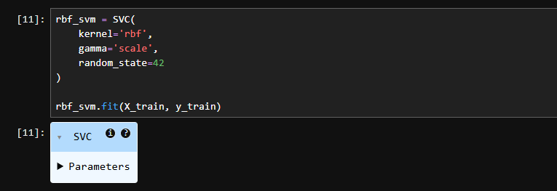

Step 12: Predictions

Step 13: Evaluate RBF SVM
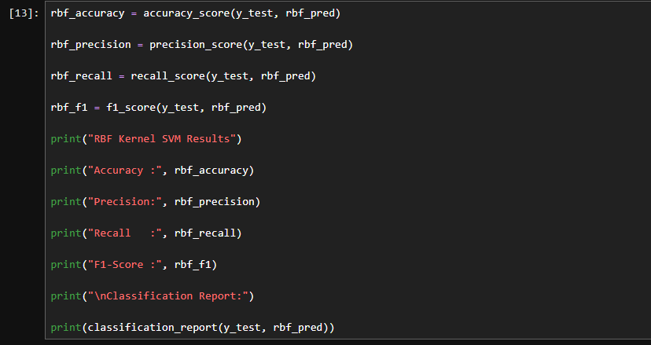
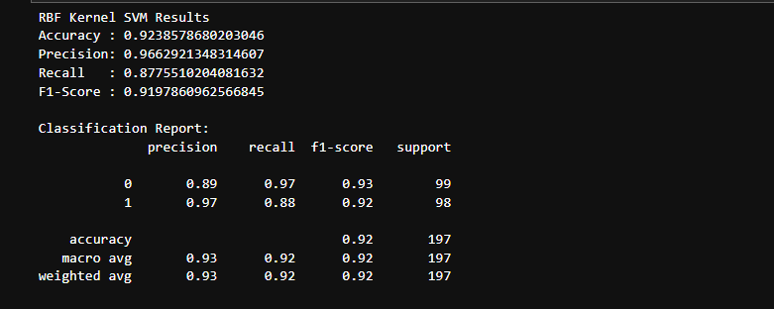

Confusion Matrix

Linear Kernel
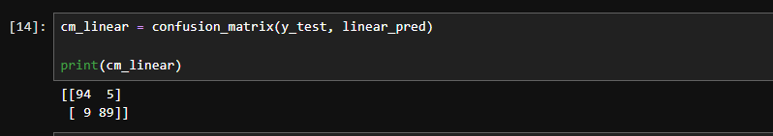

RBF Kernel
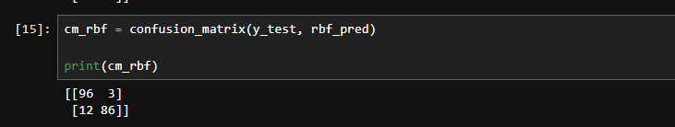

Model Comparison
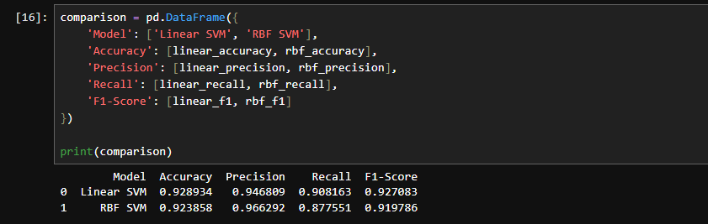

Visual Comparison
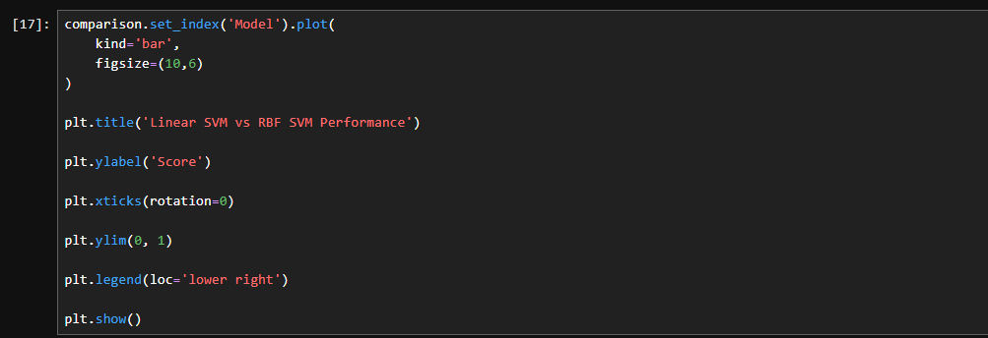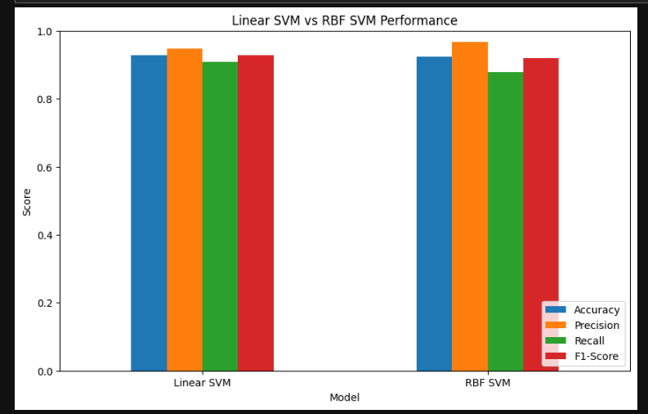

LAB-12

Customer Segmentation using K-Means and Hierarchical Clustering

Lab Title
Implementation of K-Means Clustering and Hierarchical Clustering for Customer Segmentation.

Theory

Clustering
Clustering is an unsupervised machine learning technique used to group similar data points into clusters based on their characteristics.
Unlike supervised learning, clustering does not require labeled data.

1. K-Means Clustering
K-Means is a partition-based clustering algorithm that divides the dataset into K clusters.

Working of K-Means
- Select the number of clusters (K).
- Initialize K centroids randomly.
- Assign each data point to the nearest centroid.
- Recalculate centroids.
- Repeat Steps 3 and 4 until centroids stop changing.

2. Hierarchical Clustering
Hierarchical clustering builds a hierarchy of clusters using a tree-like structure called a Dendrogram.
There are two approaches:

Agglomerative (Bottom-Up)
- Each data point starts as its own cluster.
- Closest clusters are merged repeatedly.

Divisive (Top-Down)
- Starts with one large cluster.
- Splits clusters recursively.
In this lab, we use Agglomerative Clustering.

Dataset

Dataset Name:
Shopping Mall Customer Segmentation Data
Since you already downloaded it from Kaggle, you can use the uploaded file directly.
Original Kaggle Link:
Mall Customer Segmentation Dataset

Jupyter Notebook Code

Step 1: Import Libraries
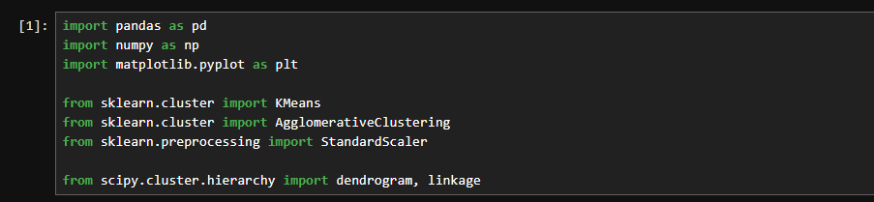

Step 2: Load Dataset
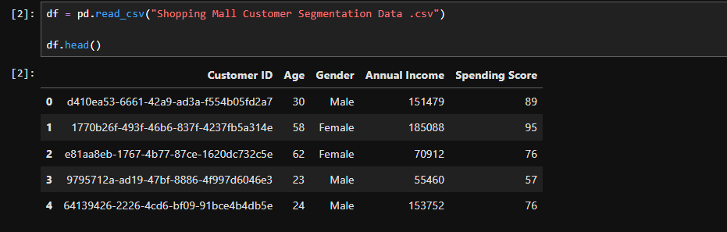

Step 3: Explore Dataset
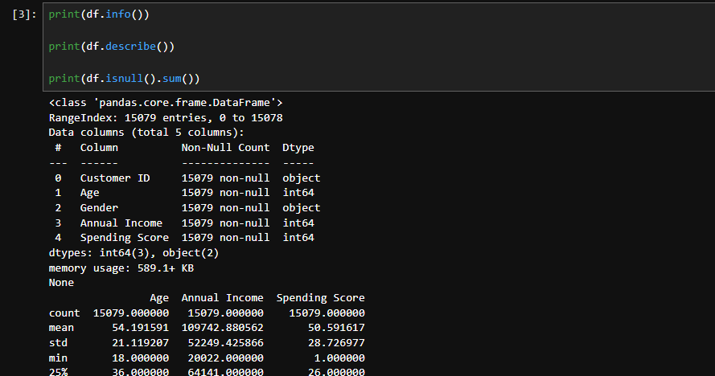

Step 4: Select Features

Step 5: Feature Scaling

Part A: K-Means Clustering

Step 6: Find Optimal Number of Clusters (Elbow Method)
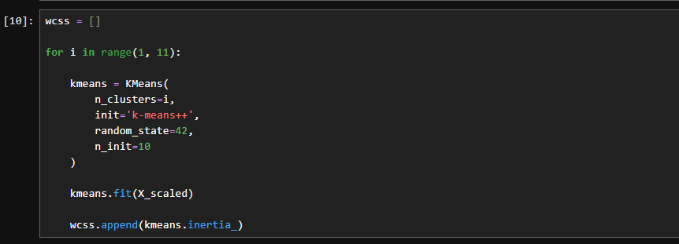

Step 7: Visualize Elbow Method
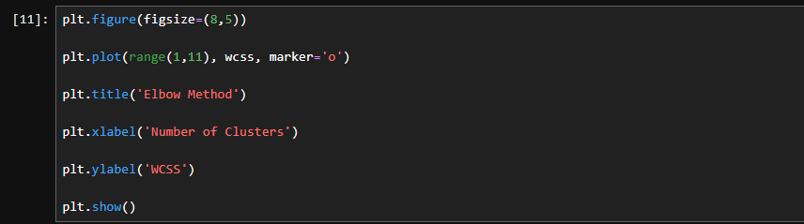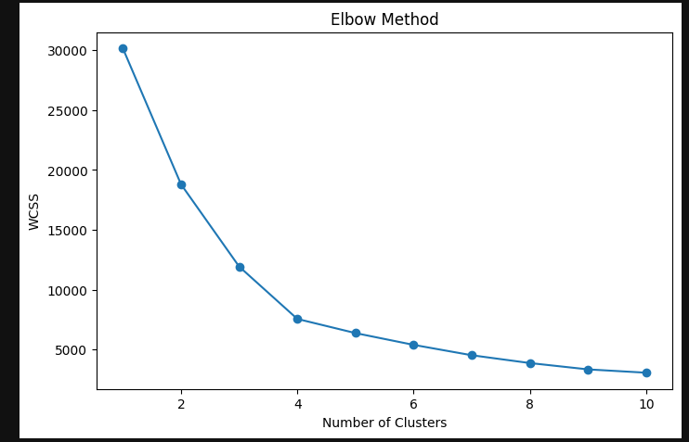

Step 8: Apply K-Means
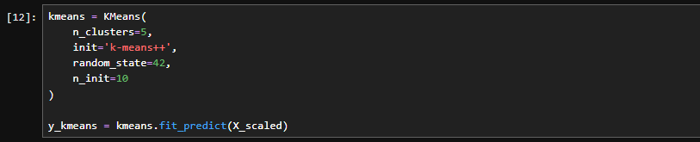

Step 9: K-Means Cluster Visualization
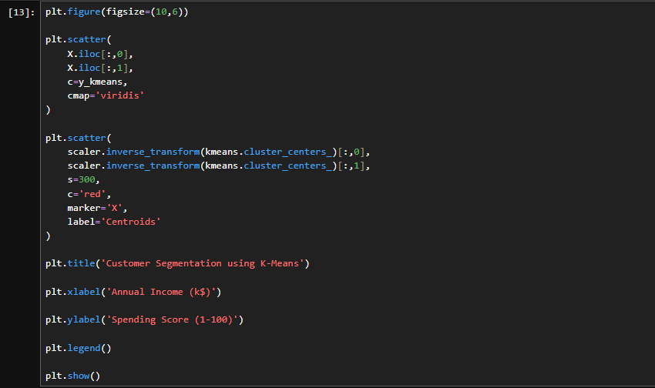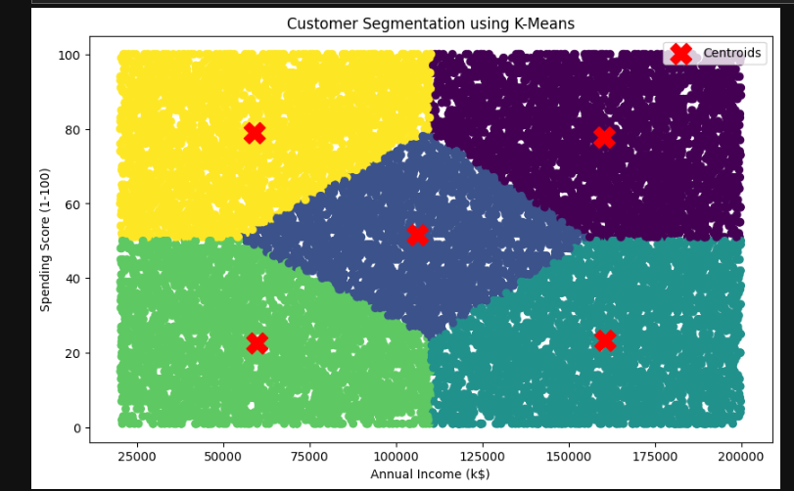

Part B: Hierarchical Clustering

Step 10: Create Dendrogram
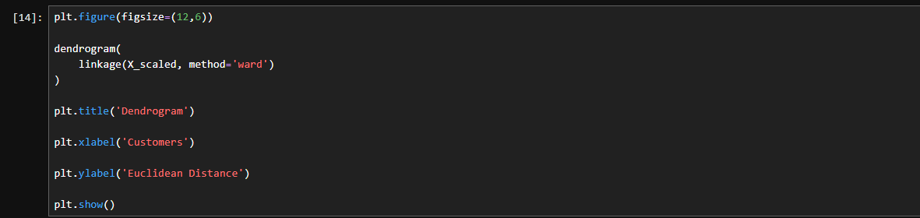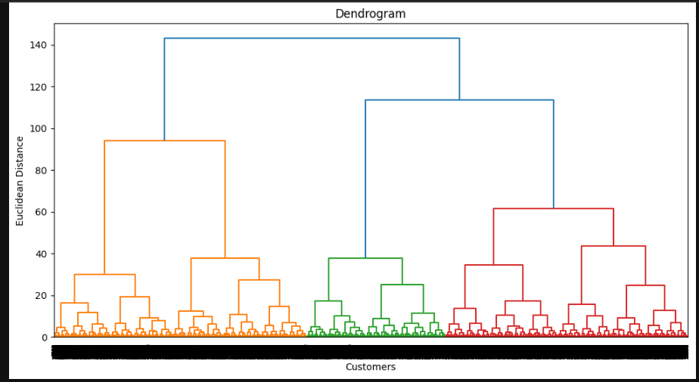

Step 11: Apply Hierarchical Clustering
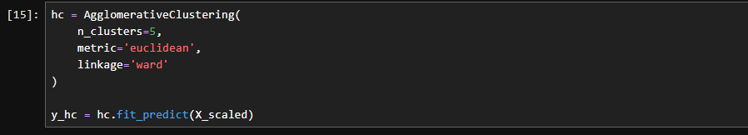

Step 12: Hierarchical Cluster Visualization
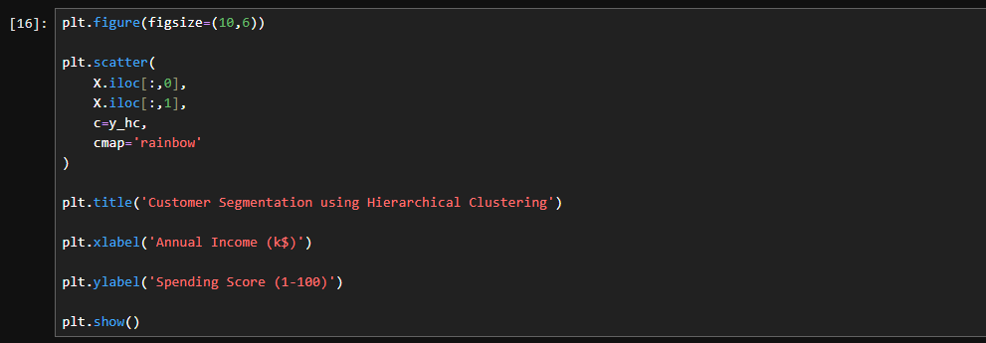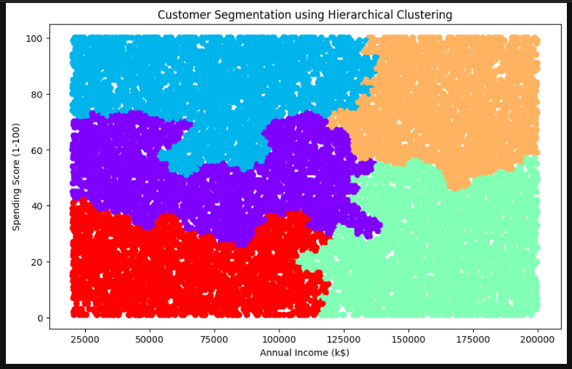

Comparison of Algorithms
Feature | K-Means | Hierarchical Clustering
Type | Partition-Based | Tree-Based
Need Number of Clusters Initially | Yes | No
Speed | Fast | Slow
Suitable for Large Data | Yes | No
Dendrogram Visualization | No | Yes
Computational Complexity | Low | High

LAB-13

Anomaly Detection in Banking Transactions using Distance-Based Outliers and Isolation Forest

Lab Title
Implementation of Distance-Based Outlier Detection and Isolation Forest for Detecting Abnormal Banking Transactions

Theory

Anomaly Detection
Anomaly detection is the process of identifying unusual patterns or observations that significantly differ from normal behavior.
In banking systems, anomaly detection is used to identify:
- Fraudulent transactions
- Money laundering activities
- Unauthorized account access
- Suspicious transaction patterns

1. Distance-Based Outlier Detection
Distance-based methods identify anomalies by measuring the distance between data points.

Concept
An observation is considered an outlier if:
- It has very few neighboring points within a specified distance.
- It lies far away from the majority of the data.
The most commonly used distance-based algorithm is:

Local Outlier Factor (LOF)
LOF compares the local density of a point with the densities of its neighbors.

2. Isolation Forest
Isolation Forest is an ensemble-based anomaly detection algorithm.

Working Principle
Instead of profiling normal data points, Isolation Forest isolates anomalies.
Anomalies:
- Are few in number.
- Have attribute values very different from normal observations.
Therefore, they require fewer splits to isolate.

Dataset
Use the Credit Card Fraud Detection Dataset from Kaggle, which is widely used for abnormal banking transaction detection.

Dataset Link:
Credit Card Fraud Detection Dataset

Jupyter Notebook Code

Step 1: Import Libraries
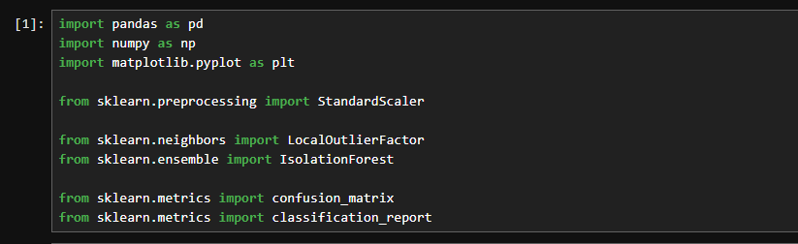

Step 2: Load Dataset
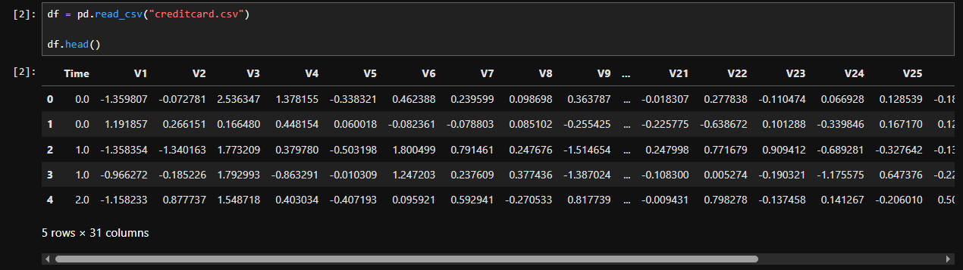

Step 3: Explore Dataset
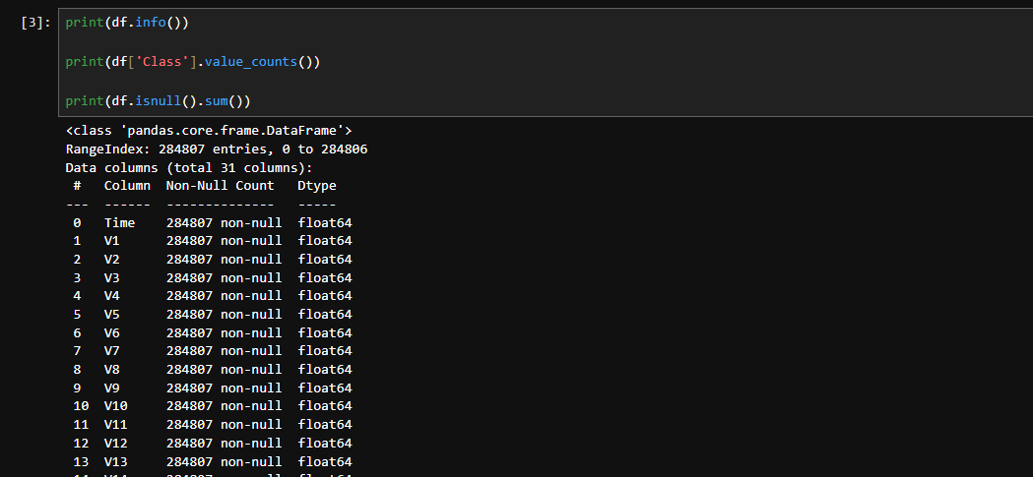

Step 4: Prepare Features and Labels
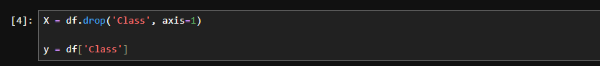

Step 5: Feature Scaling
Scale the Amount and Time features.
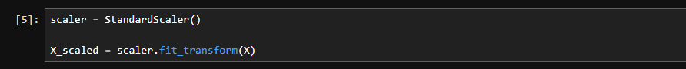

Part A: Distance-Based Outlier Detection (LOF)

Step 6: Train LOF Model
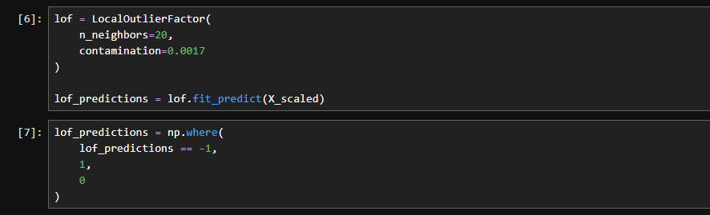

Step 7: Evaluate LOF
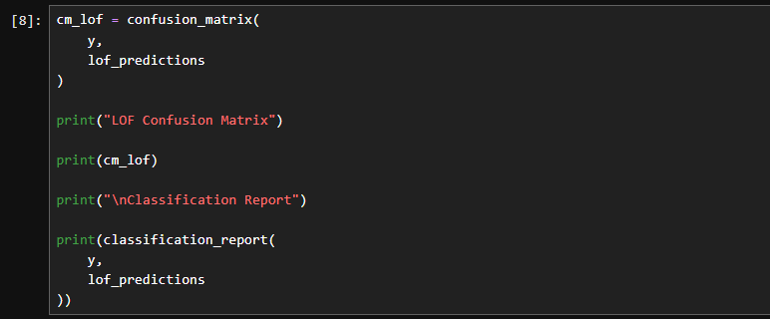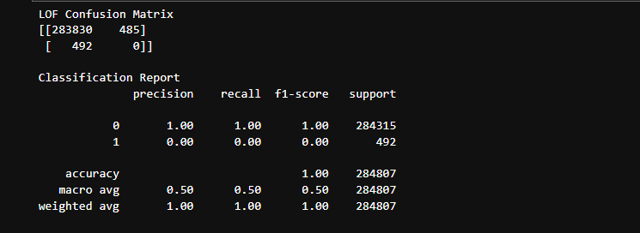

Part B: Isolation Forest

Step 8: Train Isolation Forest
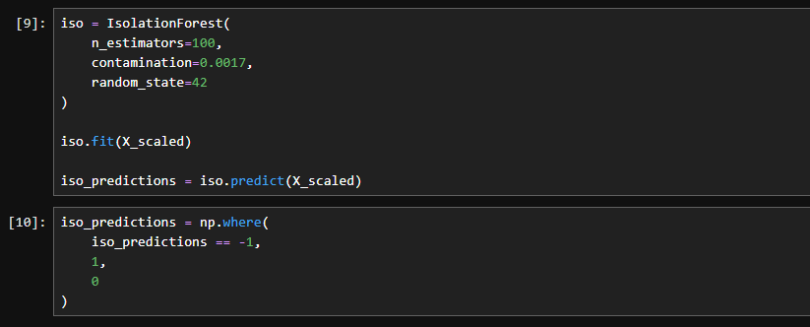

Step 9: Evaluate Isolation Forest
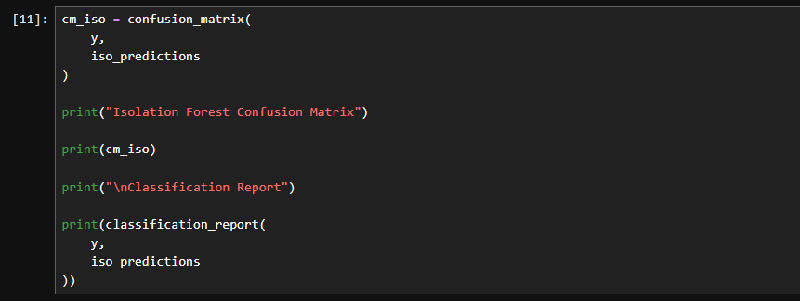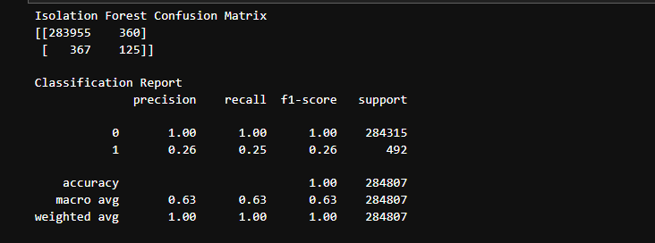

Anomaly Detection Rate (ADR)
ADR measures the proportion of actual anomalies correctly detected.
Formula:
ADR=\frac{TP}{TP+FN}
This is equivalent to Recall.

Calculate ADR

LOF
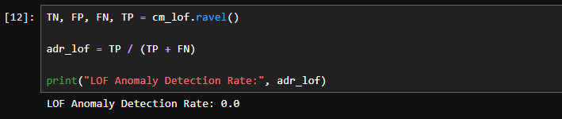

Isolation Forest
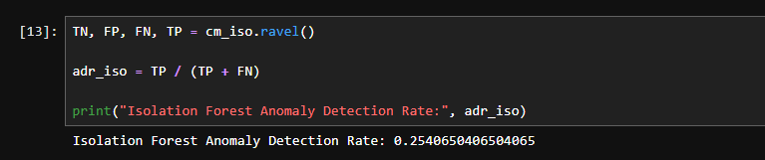

False Alarm Rate (FAR)
FAR measures the percentage of normal transactions incorrectly classified as anomalies.
Formula:
FAR=\frac{FP}{FP+TN}

Calculate FAR

LOF
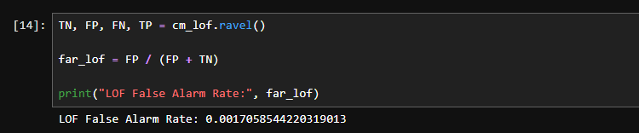

Isolation Forest
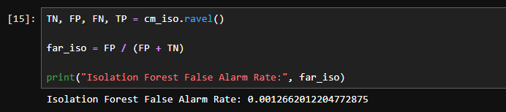

Comparison of Methods
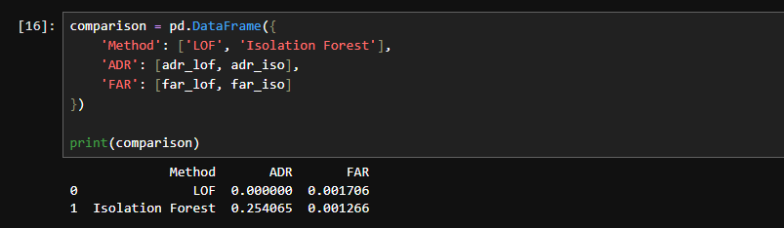

Visualization of Results
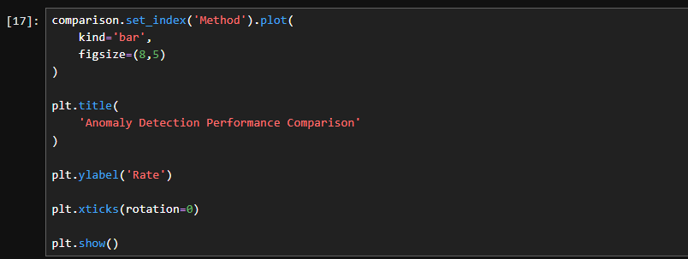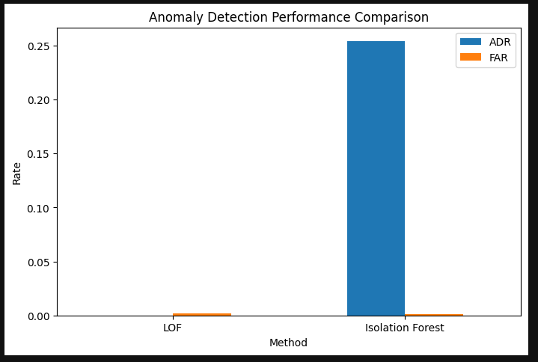

LAB-14

Social Media Data Mining and Sentiment Analysis for Product Reviews

Lab Title
Data Scraping Basics, Sentiment Analysis, and Social Media Dataset Mining for Product Review Analysis

Theory

1. Data Scraping Basics
Data scraping (Web Scraping) is the process of automatically extracting data from websites.
In sentiment analysis, data scraping is used to collect:
- Product reviews from Amazon, Daraz, etc.
- Tweets from Twitter/X.
- Customer feedback from social media.
- Comments from YouTube or Facebook.

Common Python Libraries for Data Scraping

BeautifulSoup
Used to extract information from HTML pages.
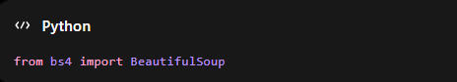

Requests
Used to send HTTP requests to websites.
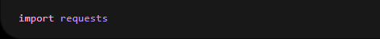

Selenium
Used for scraping dynamic websites that load content using JavaScript.

Basic Web Scraping Example
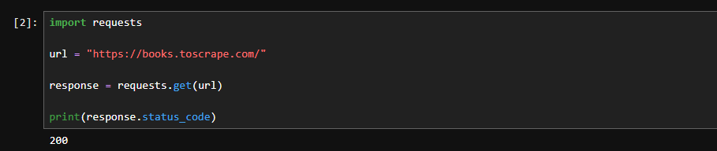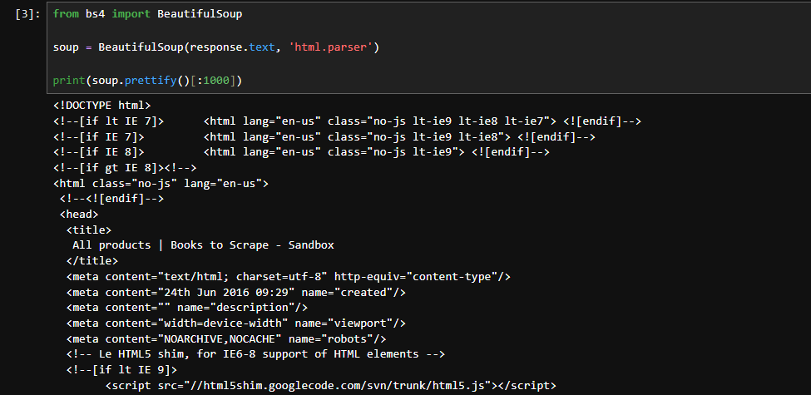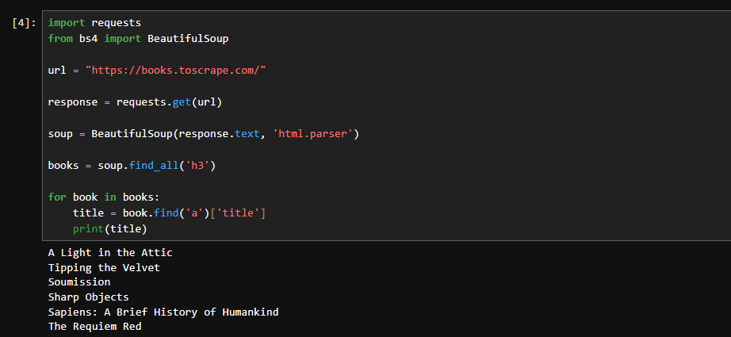
Note: Always follow a website's Terms of Service before scraping data.

2. Sentiment Analysis
Sentiment Analysis is a Natural Language Processing (NLP) technique used to determine the emotional tone of text.
It classifies text into:
- Positive Sentiment
- Negative Sentiment
- Neutral Sentiment

TextBlob Sentiment Analysis
TextBlob provides polarity scores.

Polarity Range
Polarity Score | Sentiment
> 0 | Positive
< 0 | Negative
= 0 | Neutral

3. Social Media Dataset Mining
Social media mining involves extracting useful knowledge from social media data.
Examples include:
- Understanding customer opinions.
- Detecting trends.
- Measuring brand reputation.
- Identifying consumer preferences.

Dataset
For product review sentiment analysis, use the

Dataset Link:
Use a smaller dataset:
Women's E-Commerce Clothing Reviews Dataset

Jupyter Notebook Code

Step 1: Install Required Libraries
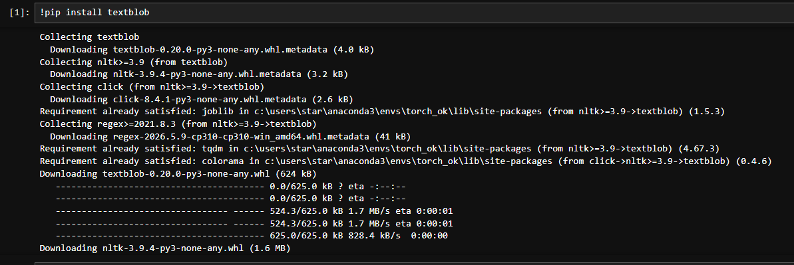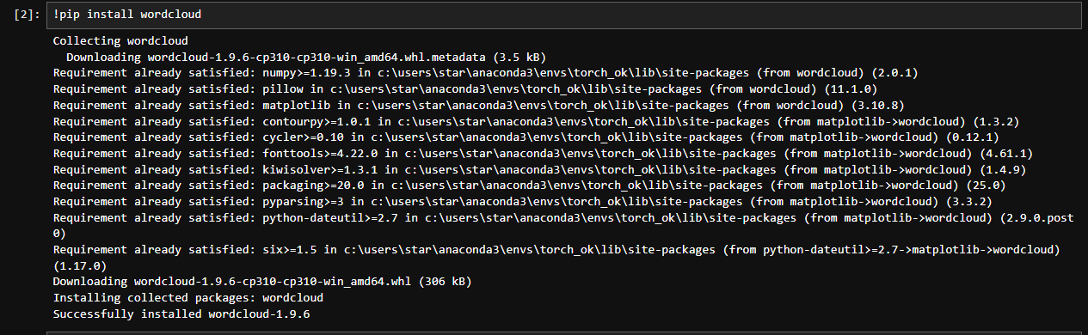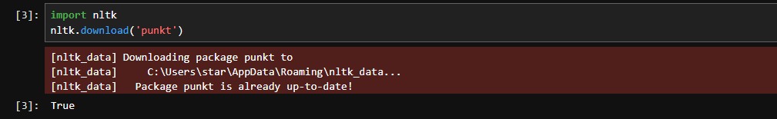

Step 2: Import Libraries
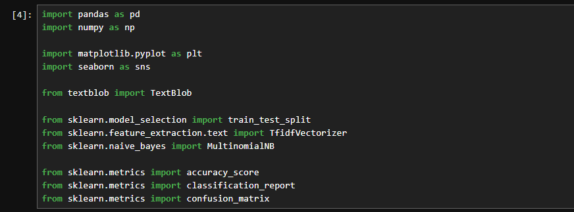

Step 3: Load Dataset
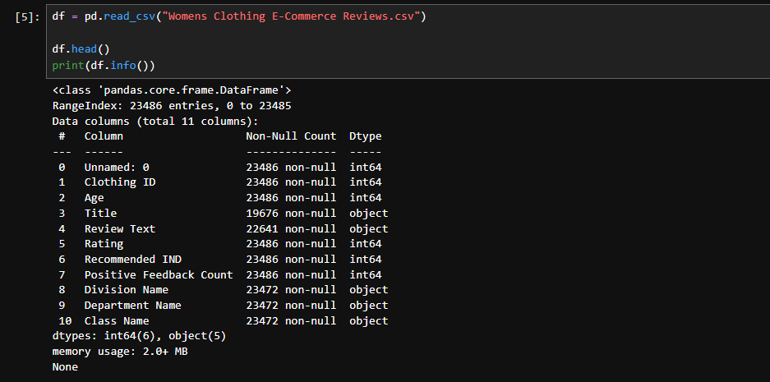

Step 4: Select Required Columns
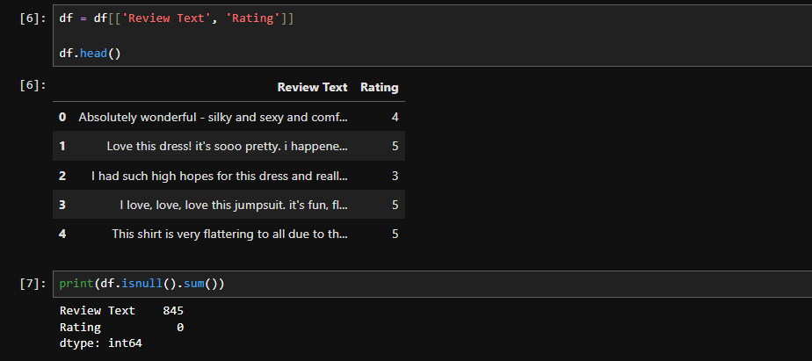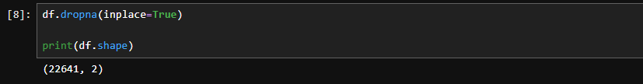

Step 5: Convert Ratings into Sentiments
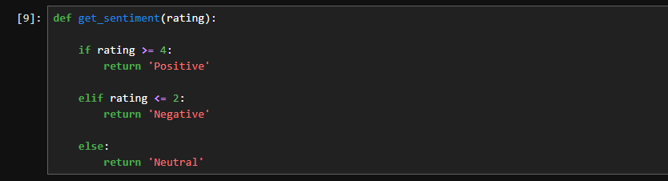
Apply:
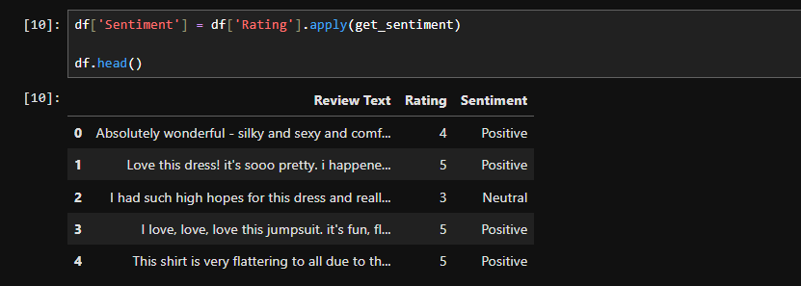

Step 6: Check Sentiment Distribution
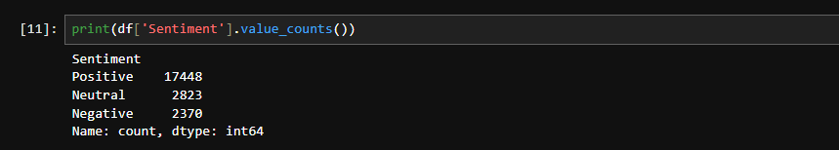
Visualization:
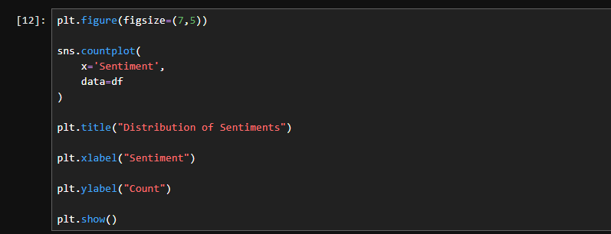
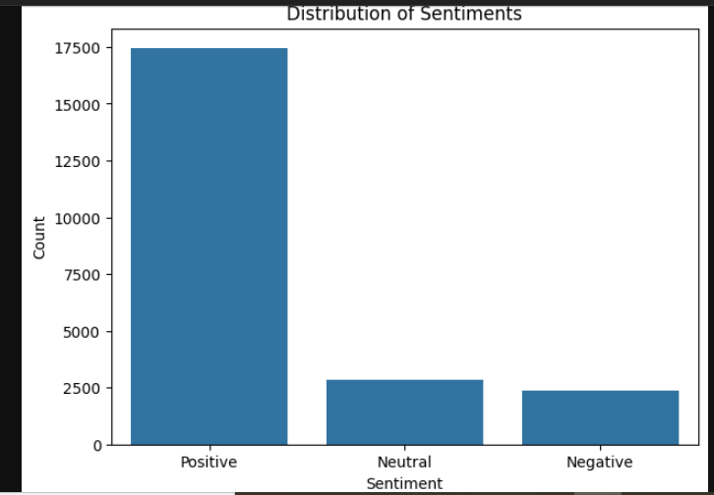

Step 7: TextBlob Sentiment Analysis
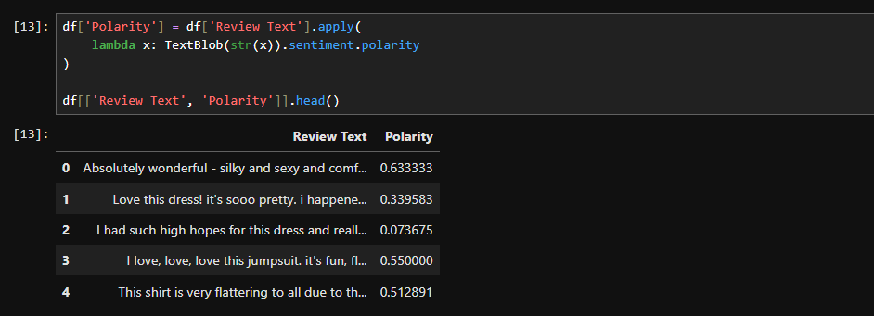

Step 8: Predict Sentiment Using Polarity
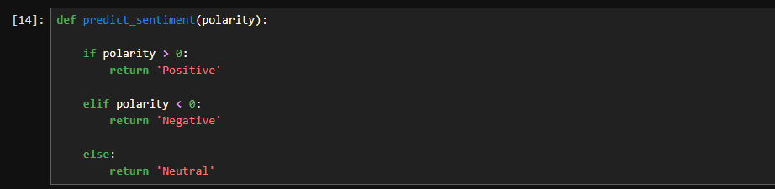

Apply:
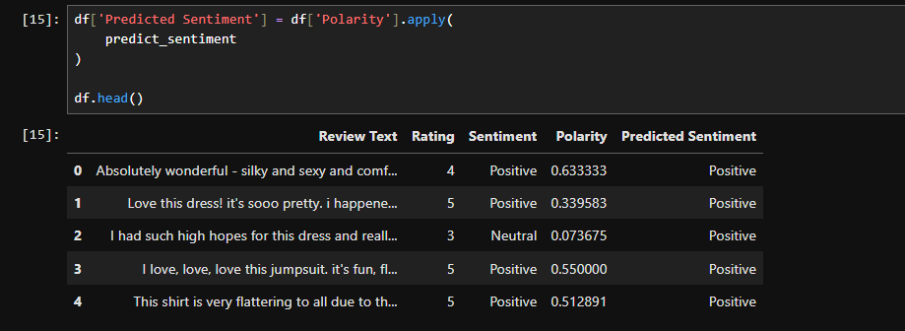

Step 9: Display Results
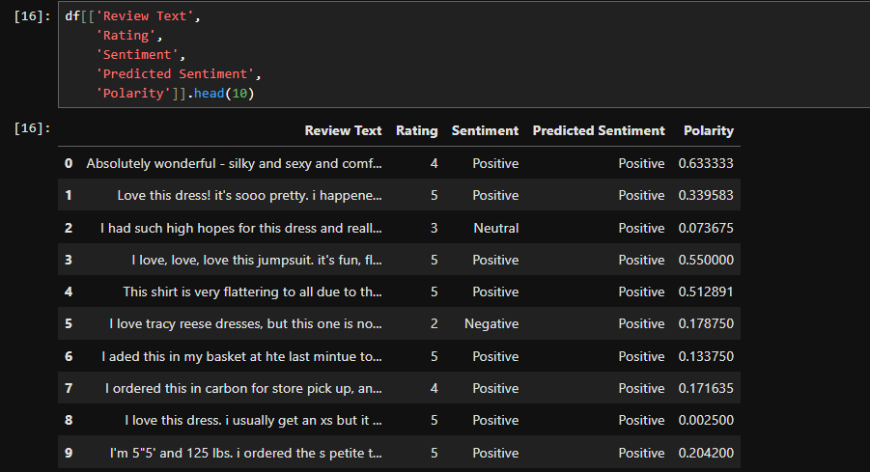

Machine Learning Based Sentiment Analysis

Step 10: Remove Neutral Reviews
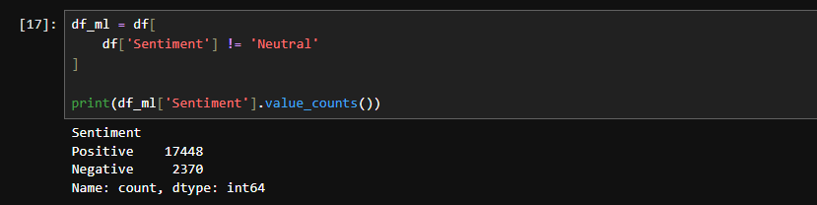

Step 11: Convert Labels to Numeric
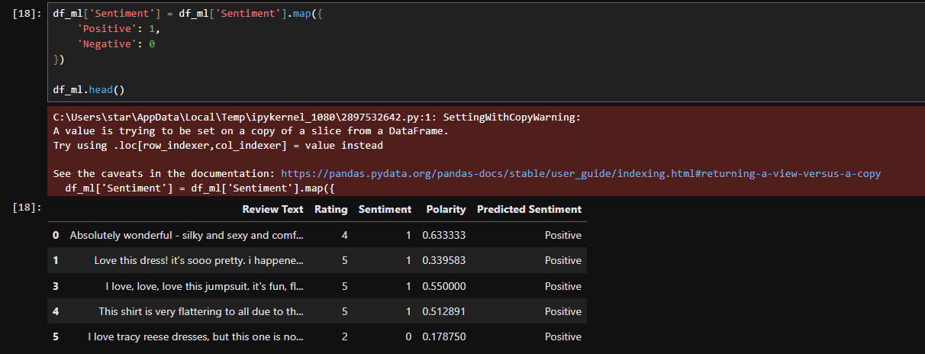

Step 12: Define Features and Labels
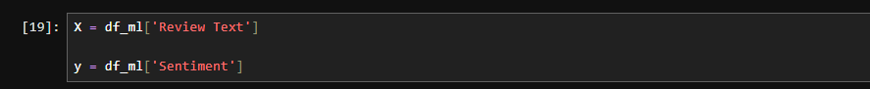

Step 13: TF-IDF Vectorization
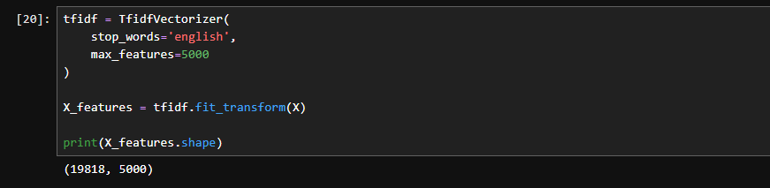

Step 14: Train-Test Split
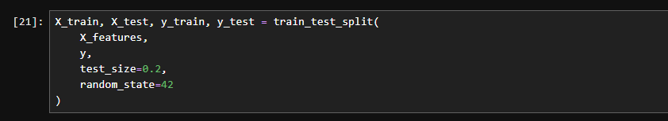

Step 15: Train Naive Bayes Model
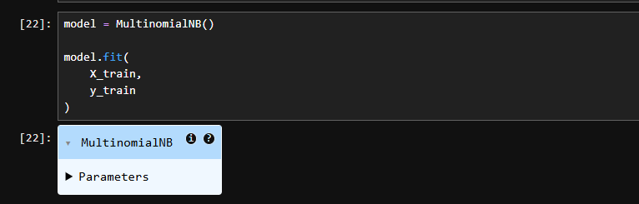

Step 16: Make Predictions
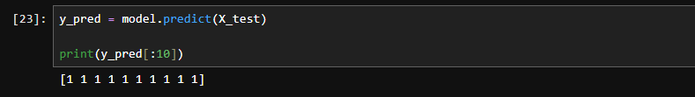

Step 17: Evaluate Model
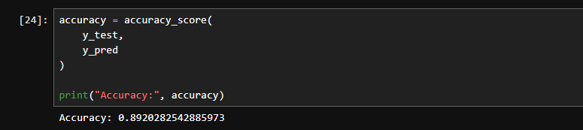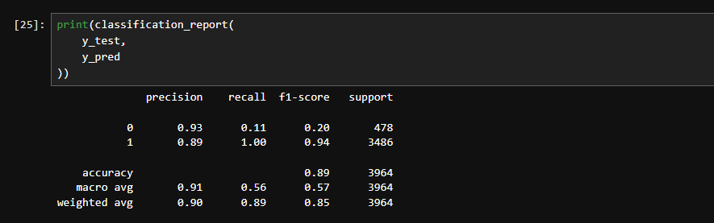

Step 18: Confusion Matrix
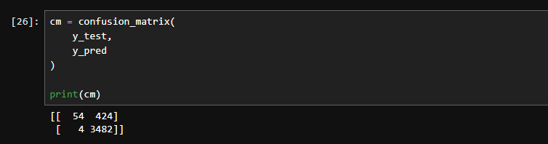
Visualization:
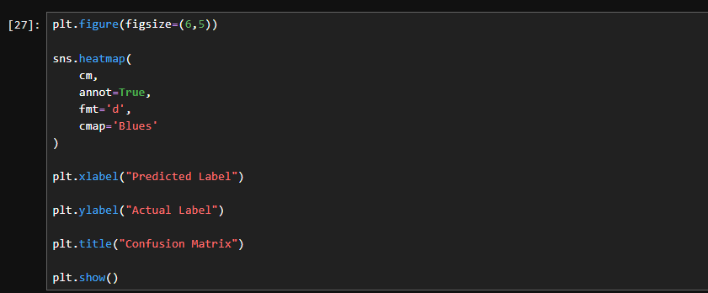
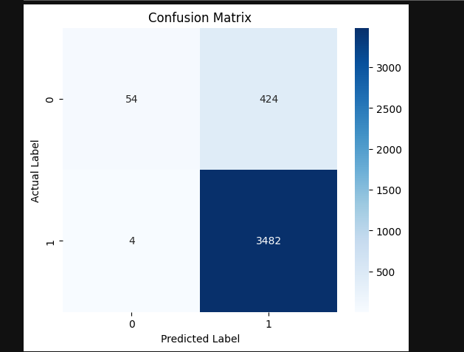

Testing on New Reviews
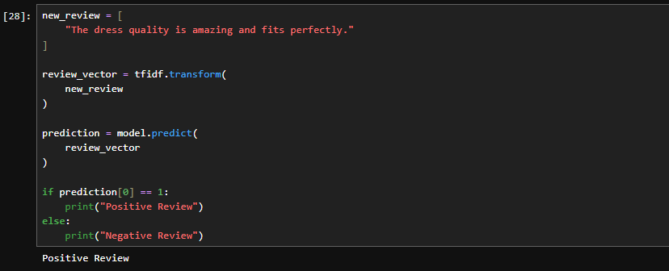

LAB-15

Comparative Analysis of Multiple Data Mining Models for Industry-Based Prediction

Lab Title
Implementation, Comparison, and Interpretation of Multiple Data Mining Models for Industry-Based Customer Response Prediction

Industry-Based Dataset
For this lab, use the Bank Marketing Dataset.

Dataset Link:
Bank Marketing Dataset (Kaggle)

Problem Statement
Predict whether a customer will subscribe to a term deposit after a marketing campaign.
Target Variable:
- yes → 1
- no → 0
This is a real-world banking industry classification problem

Theory

Models Used
Model | Type
Logistic Regression | Classification
Decision Tree | Classification
Random Forest | Ensemble Learning
Naïve Bayes | Probabilistic
K-Nearest Neighbors (KNN) | Distance-Based
Support Vector Machine (SVM) | Margin-Based
Gradient Boosting | Ensemble Learning
AdaBoost | Ensemble Learning

Why Compare Multiple Models?
Different algorithms have different strengths:
- Some perform better on linear relationships.
- Some capture complex patterns.
- Ensemble methods generally improve accuracy.
- Comparing models helps identify the most suitable solution.

Jupyter Notebook Code

Step 1: Import Libraries
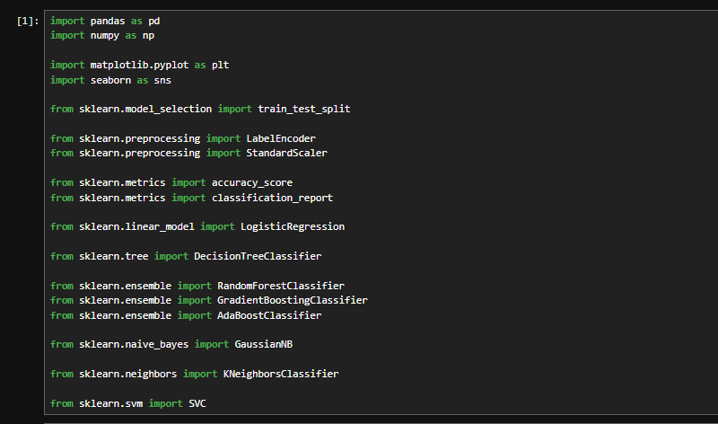

Step 2: Load Dataset
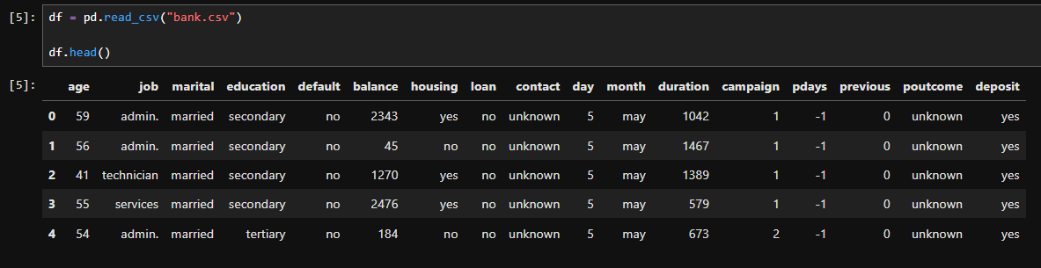

Step 3: Explore Dataset
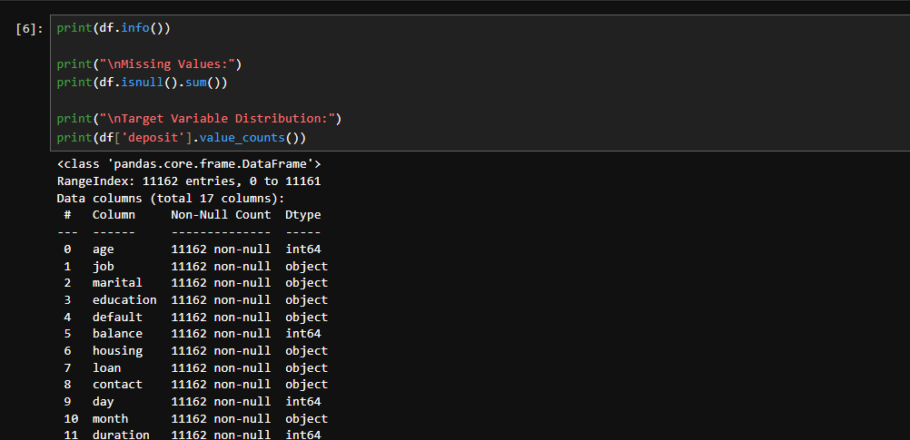

Step 4: Data Preprocessing

Convert Categorical Variables
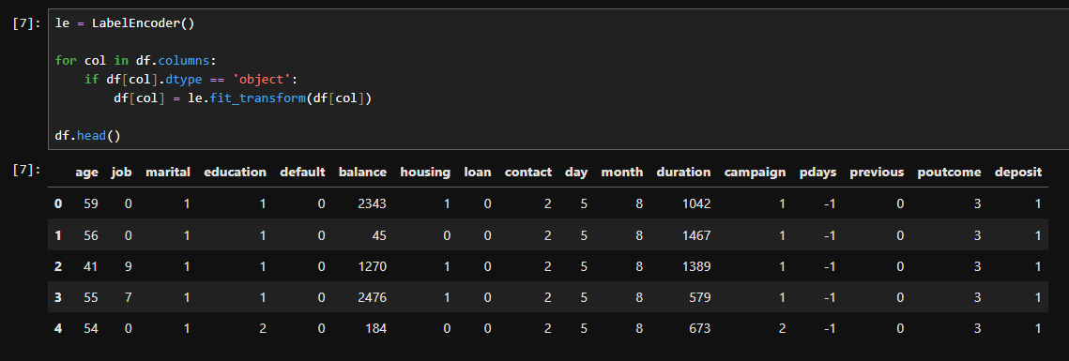

Define Features and Target

Train-Test Split
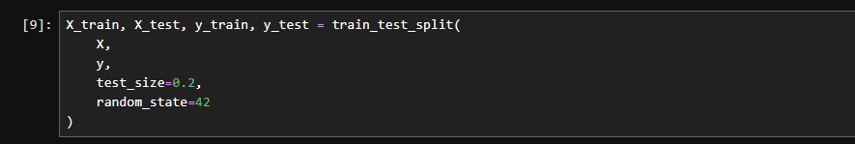

Feature Scaling
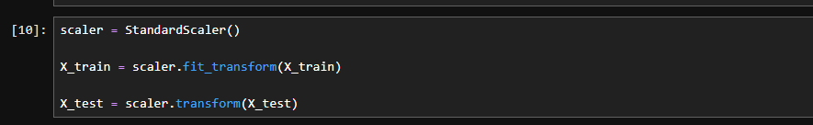

Step 5: Define Models
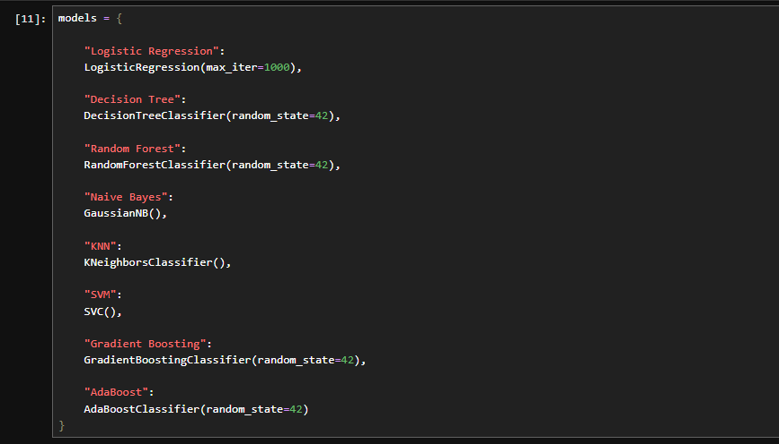

Step 6: Train and Evaluate Models
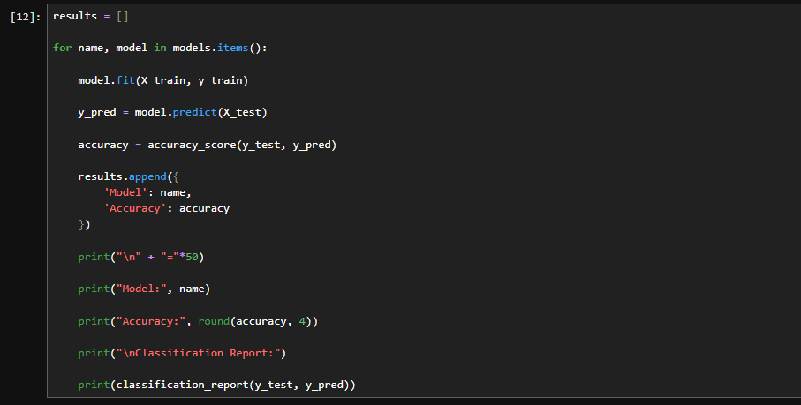

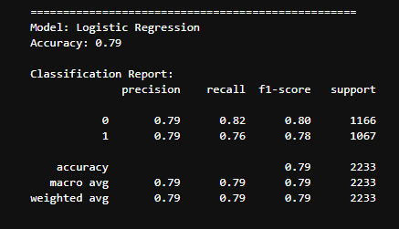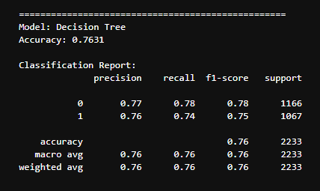
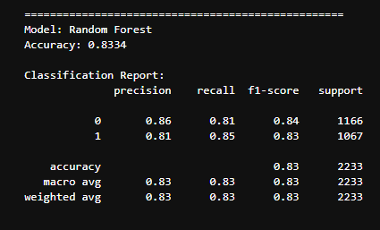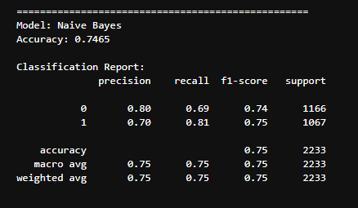
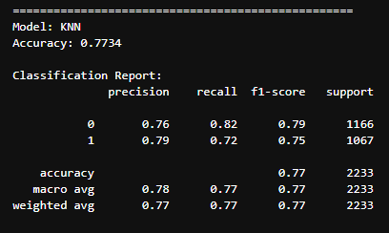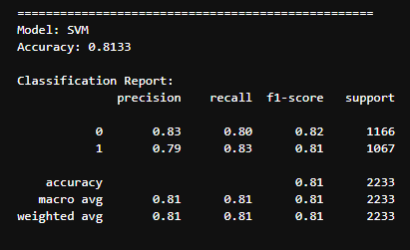
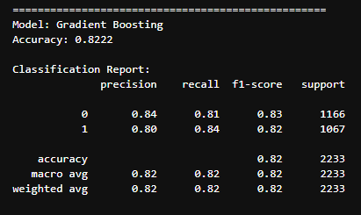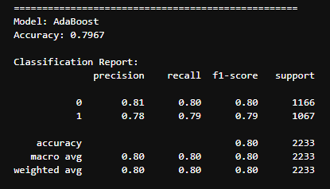

Step 7: Create Comparison Table
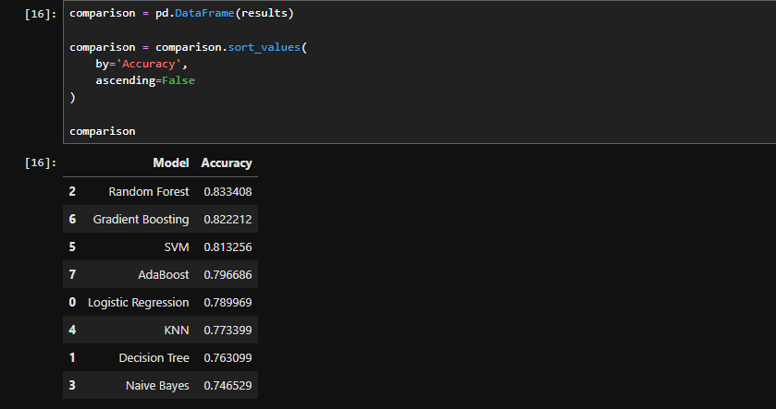

Step 8: Model Comparison Visualization
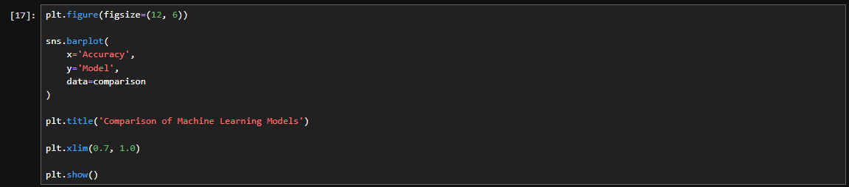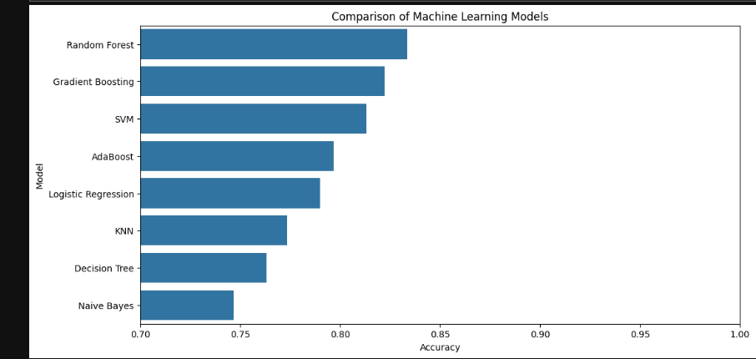

Step 9: Identify Best Model
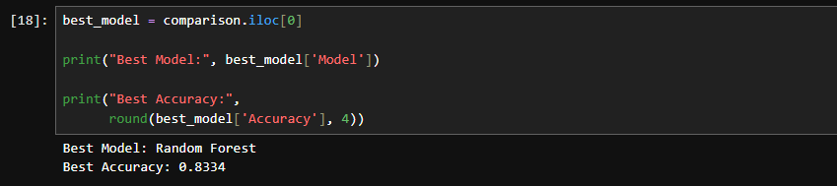

Step 10: Business Interpretation
